Talend File Management Manual | DSA


Peer Teaching Learning Activity

DSA Assignment

Talend File Management Manual

 |  | By
SL no. | Group Member Name
1. | Abhishek Khaiwale
2. | Siddhartha Kulkarni
3. | Vikramsingh Kushwaha
4. | Mehar Madnani

Guided By

Mrs. Vaishali Wangikar

Mrs. Subhangi Kale

1
Talend File Management Manual | DSA

Create a Job to Extract Delimited Data from a Field?

Function | tExtractDelimitedFields generates multiple columns from a delimited string column.
Purpose | tExtractDelimitedFields helps to extract 'fields' from within a string to write them elsewhere for example.

tExtractDelimitedFields properties
Component family | Processing/Fields
Basic settings | Field to split | Select an incoming field from the Field to split list to split.
 | Ignore NULL as the source data | Select this check box to ignore the Null value in the source data.  Clear this check box to generate the Null records that correspond to the Null value in the source data.
 | Field separator | Enter character, string or regular expression to separate fields for the transferred data.  Note  Since this component uses regex to split a filed and the regex syntax uses special characters as operators, make sure to precede the regex operator you use as a field separator by a double backslash. For example, you have to use "\\|" instead of "|".
 | Die on error | Clear the check box to skip any rows on error and complete the process for error-free rows. When errors are skipped, you can collect the rows on error using a Row > Reject link.
 | Schema and Edit Schema | A schema is a row description. It defines the number of fields (columns) to be processed and passed on to the next component. The schema is either Built-In or stored remotely in the Repository.  Click Edit schema to make changes to the schema. If the current schema is of the Repository type, three options are available:  - View schema: choose this option to view the schema only.  - Change to built-in property: choose this option to change the schema to Built-in for local changes.  - Update repository connection: choose this option to change the schema stored in the repository and decide whether to propagate the changes to all the Jobs upon completion. If you just want to propagate the changes to the current Job, you can select No upon completion and choose this schema metadata again in the [Repository Content] window.  Click Sync columns to retrieve the schema from the previous component connected in the Job.
 |  | Built-In: You create and store the schema locally for this component only. Related topic: see Talend Studio User Guide.
 |  | Repository: You have already created the schema and stored it in the Repository. You can reuse it in various projects and Job designs. Related topic: see Talend Studio User Guide.
Advanced settings | Advanced separator (for number) | Select this check box to change the separator used for numbers. By default, the thousands separator is a comma (,) and the decimal separator is a period (.).
 | Trim column | Select this check box to remove leading and trailing whitespace from all columns.
 | Check each row structure against schema | Select this check box to check whether the total number of columns in each row is consistent with the schema. If not consistent, an error message will be displayed on the console.
 | Validate date | Select this check box to check the date format strictly against the input schema.
 | tStatCatcher Statistics | Select this check box to gather the processing metadata at the Job level as well as at each component level.
Global Variables | ERROR_MESSAGE: the error message generated by the component when an error occurs. This is an After variable and it returns a string. This variable functions only if the Die on error check box is cleared, if the component has this check box.  NB_LINE: the number of rows read by an input component or transferred to an output component. This is an After variable and it returns an integer.  A Flow variable functions during the execution of a component while an After variable functions after the execution of the component.  To fill up a field or expression with a variable, press Ctrl + Space to access the variable list and choose the variable to use from it.  For further information about variables, see Talend Studio User Guide.
Usage | This component handles flow of data therefore it requires input and output components. It allows you to extract data from a delimited field, using a Row > Main link, and enables you to create a reject flow filtering data which type does not match the defined type.
Log4j | If you are using a subscription-based version of the Studio, the activity of this component can be logged using the log4jfeature. For more information on this feature, see Talend Studio User Guide.  For more information on the log4j logging levels, see the Apache documentation at http://logging.apache.org/log4j/1.2/apidocs/org/apache/log4j/Level.html.
Limitation | n/a

Scenario: Extracting a delimited string column of a database table
This scenario describes a Job that writes data including a delimited string column into a MySQL database table and displays the data on the console, then extracts the delimited string column into multiple columns and displays the data after extraction on the console.

Adding and linking components
- Create a new Job and add the following components by typing their names in the design workspace or dropping them from the Palette: a tFixedFlowInput component, a tMysqlOutput component, a tMysqlInput component, a tExtractDelimitedFields component, two tLogRowcomponents.
- Link tFixedFlowInput to tMysqlOutput using a Row > Main connection.
- Do the same to link tMysqlOutput to the first tLogRow, link tMysqlInput to tExtractDelimitedFields, link tExtractDelimitedFields to the second tLogRow.
- Link tFixedFlowInput to tMysqlInput using a Trigger > On Subjob Ok connection.

Configuring the components
Populating data in a MySQL database table
- Double-click tFixedFlowInput to open its Basic settings view.

- Click the [...] button next to Edit schema and in the pop-up window define the schema by adding three columns: Id of Integer type, and Name and DelimitedField of String type.

Click OK to close the schema editor and accept the propagation prompted by the pop-up dialog box.
- In the Mode area, select Use Inline Content(delimited file). Then in the Content field displayed, enter the data to write to the database. This input data includes a delimited string column. In this example, the input data is as follows:
- 1;AAA;32,Component Team,Developer
- 2;BBB;28,Component Team,Tester
- 3;CCC;30,Doc Team,Writer
- 4;DDD;35,Doc Team,Leader
5;EEE;33,QA Team,Tester
- Double-click tMysqlOutput to open its Basic settings view.

- Fill the Host, Port, Database, Username, Password fields with the MySQL database connection information.
- Fill the Table field with the name of the table to be written. In this example, it is employee.
- Select Drop table if exists and create from the Action on table list.
- Double-click the first tLogRow to open its Basic settings view.

In the Mode area, select Table (print values in cells of a table) for better readability of the result.
Extracting the delimited string column in the database table into multiple columns
- Double-click tMysqlInput to open its Basic settings view.

- Fill the Host, Port, Database, Username, Password fields with the MySQL database connection information.
- Click the [...] button next to Edit schema and in the pop-up window define the schema of the tMysqlInput component same as the schema of the tMysqlOutput component.

- In the Table Name field, enter the name of the table into which the data was written. In this example, it is employee.
- Click the Guess Query button to fill the Query field with the SQL query statement to be executed on the specified table. In this example, it is as follows:
- SELECT
- `employee`.`Id`,
- `employee`.`Name`,
- `employee`.`DelimitedField`
FROM `employee`
- Double-click tExtractDelimitedFields to open its Basic settings view.

- In the Field to split list, select the delimited string column to be extracted. In this example, it is DelimitedField.
In the Field separator, enter the separator used to separate the fields in the delimited string column. In this example, it is ,.
- Click the [...] button next to Edit schema and in the pop-up window define the schema by adding five columns: Id of Integer type, and Name, Age, Team, Title of String type.
In this example, the delimited string column DelimitedField is split into three columns Age, Team and Title, and the Id and Name columns are kept as well.

Click OK to close the schema editor and accept the propagation prompted by the pop-up dialog box.
- Double-click the second tLogRow to open its Basic settings view.

In the Mode area, select Table (print values in cells of a table) for better readability of the result.

Saving and executing the Job
- Press Ctrl + S to save the Job.
- Execute the Job by pressing F6 or clicking Run on the Run tab.

As shown above, the primitive input data and the data after extraction are displayed on the console, and the delimited string column DelimitedField is extracted into three columns Age, Team, and Title.

tExtractDelimitedFields properties
Component family | Processing/Fields
Basic settings | Field to split | Select an incoming field from the Field to split list to split.
 | Ignore NULL as the source data | Select this check box to ignore the Null value in the source data.  Clear this check box to generate the Null records that correspond to the Null value in the source data.
 | Field separator | Enter character, string or regular expression to separate fields for the transferred data.  Note  Since this component uses regex to split a filed and the regex syntax uses special characters as operators, make sure to precede the regex operator you use as a field separator by a double backslash. For example, you have to use "\\|" instead of "|".
 | Die on error | Clear the check box to skip any rows on error and complete the process for error-free rows. When errors are skipped, you can collect the rows on error using a Row > Reject link.
 | Schema and Edit Schema | A schema is a row description. It defines the number of fields (columns) to be processed and passed on to the next component. The schema is either Built-In or stored remotely in the Repository.  Click Edit schema to make changes to the schema. If the current schema is of the Repository type, three options are available:  - View schema: choose this option to view the schema only.  - Change to built-in property: choose this option to change the schema to Built-in for local changes.  - Update repository connection: choose this option to change the schema stored in the repository and decide whether to propagate the changes to all the Jobs upon completion. If you just want to propagate the changes to the current Job, you can select No upon completion and choose this schema metadata again in the [Repository Content] window.  Click Sync columns to retrieve the schema from the previous component connected in the Job.
 |  | Built-In: You create and store the schema locally for this component only. Related topic: see Talend Studio User Guide.
 |  | Repository: You have already created the schema and stored it in the Repository. You can reuse it in various projects and Job designs. Related topic: see Talend Studio User Guide.
Advanced settings | Advanced separator (for number) | Select this check box to change the separator used for numbers. By default, the thousands separator is a comma (,) and the decimal separator is a period (.).
 | Trim column | Select this check box to remove leading and trailing whitespace from all columns.
 | Check each row structure against schema | Select this check box to check whether the total number of columns in each row is consistent with the schema. If not consistent, an error message will be displayed on the console.
 | Validate date | Select this check box to check the date format strictly against the input schema.
 | tStatCatcher Statistics | Select this check box to gather the processing metadata at the Job level as well as at each component level.
Global Variables | ERROR_MESSAGE: the error message generated by the component when an error occurs. This is an After variable and it returns a string. This variable functions only if the Die on error check box is cleared, if the component has this check box.  NB_LINE: the number of rows read by an input component or transferred to an output component. This is an After variable and it returns an integer.  A Flow variable functions during the execution of a component while an After variable functions after the execution of the component.  To fill up a field or expression with a variable, press Ctrl + Space to access the variable list and choose the variable to use from it.  For further information about variables, see Talend Studio User Guide.
Usage | This component handles flow of data therefore it requires input and output components. It allows you to extract data from a delimited field, using a Row > Main link, and enables you to create a reject flow filtering data which type does not match the defined type.
Log4j | If you are using a subscription-based version of the Studio, the activity of this component can be logged using the log4jfeature. For more information on this feature, see Talend Studio User Guide.  For more information on the log4j logging levels, see the Apache documentation at http://logging.apache.org/log4j/1.2/apidocs/org/apache/log4j/Level.html.
Limitation | n/a

Scenario: Extracting a delimited string column of a database table
This scenario describes a Job that writes data including a delimited string column into a MySQL database table and displays the data on the console, then extracts the delimited string column into multiple columns and displays the data after extraction on the console.

Adding and linking components
- Create a new Job and add the following components by typing their names in the design workspace or dropping them from the Palette: a tFixedFlowInput component, a tMysqlOutput component, a tMysqlInput component, a tExtractDelimitedFields component, two tLogRowcomponents.
- Link tFixedFlowInput to tMysqlOutput using a Row > Main connection.
- Do the same to link tMysqlOutput to the first tLogRow, link tMysqlInput to tExtractDelimitedFields, link tExtractDelimitedFields to the second tLogRow.
- Link tFixedFlowInput to tMysqlInput using a Trigger > On Subjob Ok connection.

Configuring the components
Populating data in a MySQL database table
- Double-click tFixedFlowInput to open its Basic settings view.

- Click the [...] button next to Edit schema and in the pop-up window define the schema by adding three columns: Id of Integer type, and Name and DelimitedField of String type.

Click OK to close the schema editor and accept the propagation prompted by the pop-up dialog box.
- In the Mode area, select Use Inline Content(delimited file). Then in the Content field displayed, enter the data to write to the database. This input data includes a delimited string column. In this example, the input data is as follows:
- 1;AAA;32,Component Team,Developer
- 2;BBB;28,Component Team,Tester
- 3;CCC;30,Doc Team,Writer
- 4;DDD;35,Doc Team,Leader
5;EEE;33,QA Team,Tester
- Double-click tMysqlOutput to open its Basic settings view.

- Fill the Host, Port, Database, Username, Password fields with the MySQL database connection information.
- Fill the Table field with the name of the table to be written. In this example, it is employee.
- Select Drop table if exists and create from the Action on table list.
- Double-click the first tLogRow to open its Basic settings view.

In the Mode area, select Table (print values in cells of a table) for better readability of the result.
Extracting the delimited string column in the database table into multiple columns
- Double-click tMysqlInput to open its Basic settings view.

- Fill the Host, Port, Database, Username, Password fields with the MySQL database connection information.
- Click the [...] button next to Edit schema and in the pop-up window define the schema of the tMysqlInput component same as the schema of the tMysqlOutput component.

- In the Table Name field, enter the name of the table into which the data was written. In this example, it is employee.
- Click the Guess Query button to fill the Query field with the SQL query statement to be executed on the specified table. In this example, it is as follows:
- SELECT
- `employee`.`Id`,
- `employee`.`Name`,
- `employee`.`DelimitedField`
FROM `employee`
- Double-click tExtractDelimitedFields to open its Basic settings view.

- In the Field to split list, select the delimited string column to be extracted. In this example, it is DelimitedField.
In the Field separator, enter the separator used to separate the fields in the delimited string column. In this example, it is ,.
- Click the [...] button next to Edit schema and in the pop-up window define the schema by adding five columns: Id of Integer type, and Name, Age, Team, Title of String type.
In this example, the delimited string column DelimitedField is split into three columns Age, Team and Title, and the Id and Name columns are kept as well.

Click OK to close the schema editor and accept the propagation prompted by the pop-up dialog box.
- Double-click the second tLogRow to open its Basic settings view.

In the Mode area, select Table (print values in cells of a table) for better readability of the result.

Saving and executing the Job
- Press Ctrl + S to save the Job.
- Execute the Job by pressing F6 or clicking Run on the Run tab.

As shown above, the primitive input data and the data after extraction are displayed on the console, and the delimited string column DelimitedField is extracted into three columns Age, Team, and Title.

Create a Job to Filter Data Using tFilterRow

tFilterRow

Function | tFilterRow filters input rows by setting one or more conditions on the selected columns.
Purpose | tFilterRow helps parametrizing filters on the source data.

tFilterRow Properties
Component family | Processing
Basic settings | Schema and Edit Schema | A schema is a row description. It defines the number of fields (columns) to be processed and passed on to the next component. The schema is either Built-In or stored remotely in the Repository.  The schema of this component is built-in only.
 | Logical operator used to combine conditions | Select a logical operator to combine simple conditions and to combine the filter results of both modes if any advanced conditions are defined.  And: returns the boolean value of true if all conditions are true; otherwise false. For each two conditions combined using a logical AND, the second condition is evaluated only if the first condition is evaluated to be true.  Or: returns the boolean value of true if any condition is true; otherwise false. For each two conditions combined using a logical OR, the second condition is evaluated only if the first condition is evaluated to be false.
 | Conditions | Click the plus button to add as many simple conditions as needed. Based on the logical operator selected, the conditions are evaluated one after the other in sequential order for each row. When evaluated, each condition returns the boolean value of true or false.  Input column: Select the column of the schema the function is to be operated on  Function: Select the function on the list  Operator: Select the operator to bind the input column with the value  Value: Type in the filtered value, between quotes if needed.
 | Use advanced mode | Select this check box when the operations you want to perform cannot be carried out through the standard functions offered, for example, different logical operations in the same component. In the text field, type in the regular expression as required.  If multiple advanced conditions are defined, use a logical operator between two conditions:  && (logical AND): returns the boolean value of true if both conditions are true; otherwise false. The second condition is evaluated only if the first condition is evaluated to be true.  || (logical OR): returns the boolean value of true if either condition is true; otherwise false. The second condition is evaluated only if the first condition is evaluated to be false.
Advanced settings | tStatCatcher Statistics | Select this check box to gather the Job processing metadata at the Job level as well as at each component level.
Global Variables | ERROR_MESSAGE: the error message generated by the component when an error occurs. This is an After variable and it returns a string. This variable functions only if the Die on error check box is cleared, if the component has this check box.  NB_LINE: the number of rows read by an input component or transferred to an output component. This is an After variable and it returns an integer.  NB_LINE_OK: the number of rows matching the filter. This is an After variable and it returns an integer.  NB_LINE_REJECTED: the number of rows rejected. This is an After variable and it returns an integer.  A Flow variable functions during the execution of a component while an After variable functions after the execution of the component.  To fill up a field or expression with a variable, press Ctrl + Space to access the variable list and choose the variable to use from it.  For further information about variables, see Talend Studio User Guide.
Usage | This component is not startable (green background) and it requires an output component.
Log4j | If you are using a subscription-based version of the Studio, the activity of this component can be logged using the log4jfeature. For more information on this feature, see Talend Studio User Guide.  For more information on the log4j logging levels, see the Apache documentation at http://logging.apache.org/log4j/1.2/apidocs/org/apache/log4j/Level.html.

Scenario 1: Filtering a list of names using simple conditions
The following scenario shows a Job that uses simple conditions to filter a list of records. This scenario will output two tables: the first will list all male persons with a last name shorter than nine characters and aged between 10 and 80 years; the second will list all rejected records. An error message for each rejected record will display in the same table to explain why such a record has been rejected.

Dropping and linking components
- Drop tFixedFlowInput, tFilterRow and tLogRow from the Palette onto the design workspace.
- Connect the tFixedFlowInput to the tFilterRow, using a Row > Main link. Then, connect the tFilterRow to the tLogRow, using a Row > Filter link.
- Drop tLogRow from the Palette onto the design workspace and rename it as reject. Then, connect the tFilterRow to the reject, using a Row > Reject link.
- Label the components to better identify their roles in the Job.

Configuring the components
- Double-click tFixedFlowInput to display its Basic settings view and define its properties.
- Click the [...] button next to Edit schema to define the schema for the input data. In this example, the schema is made of the following four columns: LastName (type String), Gender (type String), Age (type Integer) and City (type String).

When done, click OK to validate the schema setting and close the dialog box. A new dialog box opens and asks you if you want to propagate the schema. Click Yes.
- Set the row and field separators in the corresponding fields if needed. In this example, use the default settings for both, namely the row separator is a carriage return and the field separator is a semi-colon.
- Select the Use Inline Content(delimited file) option in the Mode area and type in the input data in the Content field.

The input data used in this example is shown below:
Van Buren;M;73;Chicago
Adams;M;40;Albany
Jefferson;F;66;New York
Adams;M;9;Albany
Jefferson;M;30;Chicago
Carter;F;26;Chicago
Harrison;M;40;New York
Roosevelt;F;15;Chicago
Monroe;M;8;Boston
Arthur;M;20;Albany
Pierce;M;18;New York
Quincy;F;83;Albany
McKinley;M;70;Boston
Coolidge;M;4;Chicago
Monroe;M;60;Chicago
- Double-click tFilterRow to display its Basic settings view and define its properties.

- In the Conditions table, add four conditions and fill in the filtering parameters.
  - From the InputColumn list field of the first row, select LastName, from the Function list field, select Length, from the Operator list field, select Lower than, and in the Value column, type in 9 to limit the length of last names to nine characters.
  - From the InputColumn list field of the second row, select Gender, from the Operator list field, select Equals, and in the Value column, type in M in double quotes to filter records of male persons.

Warning
In the Value field, you must type in your values between double quotes for all types of values, except for integer values, which do not need quotes.
  - From the InputColumn list field of the third row, select Age, from the Operator list field, select Greater than, and in the Value column, type in 10 to set the lower limit to 10 years.
  - From the InputColumn list field of the four row, select Age, from the Operator list field, select Lower than, and in the Value column, type in80 to set the upper limit to 80 years.
- To combine the conditions, select And as that only those records that meet all the defined conditions are accepted.
- In the Basic settings of tLogRow components, select Table (print values in cells of a table) in the Mode area.

Executing the Job
- Save your Job and press F6 to execute it.

As shown above, the first table lists the records of male persons aged between 10 and 80 years, whose last names are made up of less than nine characters, and the second table lists all the records that do not match the filter conditions. Each rejected record has a corresponding error message that explains the reason of rejection.

Scenario 2: Filtering a list of names through different logical operations
Based on the previous scenario, this scenario further filters the input data so that only those records of people from New York and Chicago are accepted. Without changing the filter settings defined in the previous scenario, advanced conditions are added in this scenario to enable both logical AND and logical OR operations in the same tFilterRow component.
- Double-click the tFilterRow component to show its Basic settings view.

- Select the Use advanced mode check box, and type in the following expression in the text field:
input_row.City.equals("Chicago") || input_row.City.equals("New York")
This defines two conditions on the City column of the input data to filter records that contain the cities of Chicago and New York, and uses a logical OR to combine the two conditions so that records satisfying either condition will be accepted.
- Press Ctrl+S to save the Job and press F6 to execute it.

As shown above, the result list of the previous scenario has been further filtered, and only the records containing the cities of New York and Chicago are accepted.

tFilterRow Properties
Component family | Processing
Basic settings | Schema and Edit Schema | A schema is a row description. It defines the number of fields (columns) to be processed and passed on to the next component. The schema is either Built-In or stored remotely in the Repository.  The schema of this component is built-in only.
 | Logical operator used to combine conditions | Select a logical operator to combine simple conditions and to combine the filter results of both modes if any advanced conditions are defined.  And: returns the boolean value of true if all conditions are true; otherwise false. For each two conditions combined using a logical AND, the second condition is evaluated only if the first condition is evaluated to be true.  Or: returns the boolean value of true if any condition is true; otherwise false. For each two conditions combined using a logical OR, the second condition is evaluated only if the first condition is evaluated to be false.
 | Conditions | Click the plus button to add as many simple conditions as needed. Based on the logical operator selected, the conditions are evaluated one after the other in sequential order for each row. When evaluated, each condition returns the boolean value of true or false.  Input column: Select the column of the schema the function is to be operated on  Function: Select the function on the list  Operator: Select the operator to bind the input column with the value  Value: Type in the filtered value, between quotes if needed.
 | Use advanced mode | Select this check box when the operations you want to perform cannot be carried out through the standard functions offered, for example, different logical operations in the same component. In the text field, type in the regular expression as required.  If multiple advanced conditions are defined, use a logical operator between two conditions:  && (logical AND): returns the boolean value of true if both conditions are true; otherwise false. The second condition is evaluated only if the first condition is evaluated to be true.  || (logical OR): returns the boolean value of true if either condition is true; otherwise false. The second condition is evaluated only if the first condition is evaluated to be false.
Advanced settings | tStatCatcher Statistics | Select this check box to gather the Job processing metadata at the Job level as well as at each component level.
Global Variables | ERROR_MESSAGE: the error message generated by the component when an error occurs. This is an After variable and it returns a string. This variable functions only if the Die on error check box is cleared, if the component has this check box.  NB_LINE: the number of rows read by an input component or transferred to an output component. This is an After variable and it returns an integer.  NB_LINE_OK: the number of rows matching the filter. This is an After variable and it returns an integer.  NB_LINE_REJECTED: the number of rows rejected. This is an After variable and it returns an integer.  A Flow variable functions during the execution of a component while an After variable functions after the execution of the component.  To fill up a field or expression with a variable, press Ctrl + Space to access the variable list and choose the variable to use from it.  For further information about variables, see Talend Studio User Guide.
Usage | This component is not startable (green background) and it requires an output component.
Log4j | If you are using a subscription-based version of the Studio, the activity of this component can be logged using the log4jfeature. For more information on this feature, see Talend Studio User Guide.  For more information on the log4j logging levels, see the Apache documentation at http://logging.apache.org/log4j/1.2/apidocs/org/apache/log4j/Level.html.

Scenario 1: Filtering a list of names using simple conditions
The following scenario shows a Job that uses simple conditions to filter a list of records. This scenario will output two tables: the first will list all male persons with a last name shorter than nine characters and aged between 10 and 80 years; the second will list all rejected records. An error message for each rejected record will display in the same table to explain why such a record has been rejected.

Dropping and linking components
- Drop tFixedFlowInput, tFilterRow and tLogRow from the Palette onto the design workspace.
- Connect the tFixedFlowInput to the tFilterRow, using a Row > Main link. Then, connect the tFilterRow to the tLogRow, using a Row > Filter link.
- Drop tLogRow from the Palette onto the design workspace and rename it as reject. Then, connect the tFilterRow to the reject, using a Row > Reject link.
- Label the components to better identify their roles in the Job.

Configuring the components
- Double-click tFixedFlowInput to display its Basic settings view and define its properties.
- Click the [...] button next to Edit schema to define the schema for the input data. In this example, the schema is made of the following four columns: LastName (type String), Gender (type String), Age (type Integer) and City (type String).

When done, click OK to validate the schema setting and close the dialog box. A new dialog box opens and asks you if you want to propagate the schema. Click Yes.
- Set the row and field separators in the corresponding fields if needed. In this example, use the default settings for both, namely the row separator is a carriage return and the field separator is a semi-colon.
- Select the Use Inline Content(delimited file) option in the Mode area and type in the input data in the Content field.

The input data used in this example is shown below:
Van Buren;M;73;Chicago
Adams;M;40;Albany
Jefferson;F;66;New York
Adams;M;9;Albany
Jefferson;M;30;Chicago
Carter;F;26;Chicago
Harrison;M;40;New York
Roosevelt;F;15;Chicago
Monroe;M;8;Boston
Arthur;M;20;Albany
Pierce;M;18;New York
Quincy;F;83;Albany
McKinley;M;70;Boston
Coolidge;M;4;Chicago
Monroe;M;60;Chicago
- Double-click tFilterRow to display its Basic settings view and define its properties.

- In the Conditions table, add four conditions and fill in the filtering parameters.
  - From the InputColumn list field of the first row, select LastName, from the Function list field, select Length, from the Operator list field, select Lower than, and in the Value column, type in 9 to limit the length of last names to nine characters.
  - From the InputColumn list field of the second row, select Gender, from the Operator list field, select Equals, and in the Value column, type in M in double quotes to filter records of male persons.

Warning
In the Value field, you must type in your values between double quotes for all types of values, except for integer values, which do not need quotes.
  - From the InputColumn list field of the third row, select Age, from the Operator list field, select Greater than, and in the Value column, type in 10 to set the lower limit to 10 years.
  - From the InputColumn list field of the four row, select Age, from the Operator list field, select Lower than, and in the Value column, type in80 to set the upper limit to 80 years.
- To combine the conditions, select And as that only those records that meet all the defined conditions are accepted.
- In the Basic settings of tLogRow components, select Table (print values in cells of a table) in the Mode area.

Executing the Job
- Save your Job and press F6 to execute it.

As shown above, the first table lists the records of male persons aged between 10 and 80 years, whose last names are made up of less than nine characters, and the second table lists all the records that do not match the filter conditions. Each rejected record has a corresponding error message that explains the reason of rejection.

Scenario 2: Filtering a list of names through different logical operations
Based on the previous scenario, this scenario further filters the input data so that only those records of people from New York and Chicago are accepted. Without changing the filter settings defined in the previous scenario, advanced conditions are added in this scenario to enable both logical AND and logical OR operations in the same tFilterRow component.
- Double-click the tFilterRow component to show its Basic settings view.

- Select the Use advanced mode check box, and type in the following expression in the text field:
input_row.City.equals("Chicago") || input_row.City.equals("New York")
This defines two conditions on the City column of the input data to filter records that contain the cities of Chicago and New York, and uses a logical OR to combine the two conditions so that records satisfying either condition will be accepted.
- Press Ctrl+S to save the Job and press F6 to execute it.

As shown above, the result list of the previous scenario has been further filtered, and only the records containing the cities of New York and Chicago are accepted.

tSchemaComplianceCheck

Function | Validates all input rows against a reference schema or check types, nullability, length of rows against reference values. The validation can be carried out in full or partly.
Purpose | Helps to ensure the data quality of any source data against a reference data source.
Depending on the Talend solution you are using, this component can be used in one, some or all of the following Job frameworks:
- Standard: see tSchemaComplianceCheck Properties.
The component in this framework is generally available.
- MapReduce: see tSchemaComplianceCheck in Talend Map/Reduce Jobs.
The component in this framework is available when you have subscribed to one of the Talend solutions with Big Data.

tSchemaComplianceCheck Properties
Component family | Data Quality
Basic settings | Base Schema and Edit schema | A schema is a row description. It defines the number of fields (columns) to be processed and passed on to the next component. The schema is either Built-In or stored remotely in the Repository.  It describes the structure and nature of your data to be processed as it is.
 |  | Built-In: You create and store the schema locally for this component only. Related topic: see Talend Studio User Guide.
 |  | Repository: You have already created the schema and stored it in the Repository. You can reuse it in various projects and Job designs. Related topic: see Talend Studio User Guide.
 | Check all columns from schema | Select this option to carry out all checks on all columns against the base schema.
 | Custom defined | Select this option to carry out particular checks on particular columns. When this option is selected, the Checked Columnstable shows.
 | Checked Columns | In this table, define what checks are to be carried out on which columns.
 |  | Column: Displays the columns names.
 |  | Type: Select the type of data each column is supposed to contain. This validation is mandatory for all columns.
 |  | Date pattern: Define the expected date format for each column with the data type of Date.
 |  | Nullable: Select the check box in an individual column to define the column to be nullable, that is, to allow empty rows in this column to go to the output flow regardless of the base schema definition. To define all columns to be nullable, select the check box in the table header.
 |  | Undefined or empty: Select the check box in an individual column to reject empty rows in this column while the column is not nullable in the base schema definition. To carry out this verification on all the columns, select the check box in the table header.
 |  | Max length: Select the check box in an individual column to verify the data length of the column against the length definition of the base schema. To carry out this verification on all the columns, select the check box in the table header.
 | Use another schema for compliance check | Define a reference schema as you expect the data to be, in order to reject the non-compliant data.  It can be restrictive on data type, null values, and/or length.
 | Trim the excess content of column when length checking chosen and the length is greater than defined length | With any of the three modes of tSchemaComplianceCheck, select this check box to truncate the data that exceeds the length specified rather than reject it.  Note  This option is applicable only on data of String type.
Advanced settings | Use Fastest Date Check | Select this check box to perform a fast date format check using the TalendDate.isDate() method of the TalendDatesystem routine if Date pattern is not defined. For more information about routines, see Talend Studio User Guide.
 | Ignore TimeZone when Check Date | Select this check box to ignore the time zone setup upon date check.  Not available when the Check all columns from schemamode is selected.
 | Treat all empty string as NULL | Select this check box to treat any empty fields in any columns as null values, instead of empty strings.  By default, this check box is selected. When it is cleared, the Choose Column(s) table shows to let you select individual columns.
 | tStatCatcher Statistics | Select this check box to collect log data at the component level.
Global Variables | ERROR_MESSAGE: the error message generated by the component when an error occurs. This is an After variable and it returns a string. This variable functions only if the Die on error check box is cleared, if the component has this check box.  A Flow variable functions during the execution of a component while an After variable functions after the execution of the component.  To fill up a field or expression with a variable, press Ctrl + Space to access the variable list and choose the variable to use from it.  For further information about variables, see Talend Studio User Guide.
Usage | This component is an intermediary step in the flow allowing to exclude from the main flow the non-compliant data. This component cannot be a start component as it requires an input flow. It also requires at least one output component to gather the validated flow, and possibly a second output component for rejected data using Rejects link. For more information, see Talend Studio User Guide.

Scenario: Validating data against schema
This scenario presents a Job that checks the type, nullability and length of data from an incoming flow against a defined reference schema, and displays the validation results on the Run console.
The incoming flow comes from a simple CSV file that contains heterogeneous data including wrong data type, data exceeding the maximum length, wrong ID and null values in non-nullable columns, as shown below:
ID;Name;BirthDate;State;City
1;Dwight;06-04-2008;Delaware;Concord
2;Warren;25-10-2008;Montana
3;Benjamin;17-08-2008;Washington;Austin
4;Harry;14-04-2008;Kansas;Annapolis
5;Ulysses;2007-04-12;Michigan;Raleigh
6;James;19-08-2007;Delaware;Charleston
.7;Bill;20-04-2007;Illinois;Bismarck
8;Ulysses;04-12-2008;;Saint Paul
9;Thomas;09-05-2008;Maryland;Albany
10;Ronald;11-02-2008;Florida;Hartford

Setting up the Job
- Drop the following components: a tFileInputDelimited, a tSchemaComplianceCheck, and two tLogRow components from the Palette to the design workspace.
- Connect the tFileInputDelimited component to the tSchemaComplianceCheck component using a Row > Main connection.
- Connect the tSchemaComplianceCheck component to the first tLogRow component using a Row > Main connection. This output flow will gather the valid data.
- Connect the tSchemaComplianceCheck component to the second tLogRow component using a Row > Rejects connection. This second output flow will gather the non-compliant data. It passes two additional columns to the next component: ErrorCode and ErrorMessage. These two read-only columns provide information about the rejected data to ease error handling and troubleshooting if needed.

Configuring the components
- Double-click the tFileInputDelimited component to display its Basic settings view and define the basic parameters including the input file name and the number of header rows to skip.

- Click the [...] button next to Edit schema to describe the data structure of the input file. In this use case, the schema is made of five columns: ID, Name, BirthDate, State, and City.

- Fill the Length field for the Name, State and City columns with 7, 10 and 10 respectively. Then click OK to close the schema dialog box and propagate the schema.
- Double-click the tSchemaComplianceCheck component to display its Basic settings view, wherein you will define most of the validation parameters.

- Select the Custom defined option in the Mode area to perform custom defined checks.
In this example, we use the Checked columns table to set the validation parameters. However, you can also select the Check all columns from schema check box if you want to perform all the checks (type, nullability and length) on all the columns against the base schema, or select the Use another schema for compliance check option and define a new schema as the expected structure of the data.
- In the Checked Columns table, define the checks to be performed. In this use case:
- The type of the ID column should be Int.
- The length of the Name, State and City columns should be checked.
- The type of the BirthDate column should be Date, and the expected date pattern is dd-MM-yyyy.
- All the columns should be checked for null values, so clear the Nullable check box for all the columns.

Note
To send rows containing fields exceeding the defined maximum length to the reject flow, make sure that the Trim the excess content of column when length checking chosen and the length is greater than defined length check box is cleared.
- In the Advanced settings view of the tSchemaComplianceCheck component, select the Treat all empty string as NULL option to sent any rows containing empty fields to the reject flow.
- To view the validation result in tables on the Run console, double-click each tLogRow component and select the Table option in the Basic settingsview.

Executing the Job
- Save your Job and press F6 to launch it.
Two tables are displayed on the console, showing the valid data and rejected data respectively.

tSchemaComplianceCheck in Talend Map/Reduce Jobs

Warning
The information in this section is only for users that have subscribed to one of the Talend solutions with Big Data and is not applicable to Talend Open Studio for Big Data users.
In a Talend Map/Reduce Job, tSchemaComplianceCheck, as well as the other Map/Reduce components preceding it, generates native Map/Reduce code. This section presents the specific properties of tSchemaComplianceCheck when it is used in that situation. For further information about a Talend Map/Reduce Job, see Talend Big Data Getting Started Guide.
Component family | Data Quality
Basic settings | Base Schema and Edit schema | A schema is a row description. It defines the number of fields (columns) to be processed and passed on to the next component. The schema is either Built-In or stored remotely in the Repository.  It describes the structure and nature of your data to be processed as it is.
 |  | Built-In: You create and store the schema locally for this component only. Related topic: see Talend Studio User Guide.
 |  | Repository: You have already created the schema and stored it in the Repository. You can reuse it in various projects and Job designs. Related topic: see Talend Studio User Guide.
 | Check all columns from schema | Select this option to carry out all checks on all columns against the base schema.
 | Custom defined | Select this option to carry out particular checks on particular columns. When this option is selected, the Checked Columns table shows.
 | Checked Columns | In this table, define what checks are to be carried out on which columns.
 |  | Column: Displays the columns names.
 |  | Type: Select the type of data each column is supposed to contain. This validation is mandatory for all columns.
 |  | Date pattern: Define the expected date format for each column with the data type of Date.
 |  | Nullable: Select the check box in an individual column to define the column to be nullable, that is, to allow empty rows in this column to go to the output flow regardless of the base schema definition. To define all columns to be nullable, select the check box in the table header.
 |  | Undefined or empty: Select the check box in an individual column to reject empty rows in this column while the column is not nullable in the base schema definition. To carry out this verification on all the columns, select the check box in the table header.
 |  | Max length: Select the check box in an individual column to verify the data length of the column against the length definition of the base schema. To carry out this verification on all the columns, select the check box in the table header.
 | Use another schema for compliance check | Define a reference schema as you expect the data to be, in order to reject the non-compliant data.  It can be restrictive on data type, null values, and/or length.
 | Trim the excess content of column when length checking chosen and the length is greater than defined length | With any of the three modes of tSchemaComplianceCheck, select this check box to truncate the data that exceeds the length specified rather than reject it.  Note  This option is applicable only on data of String type.
Advanced settings | Use Fastest Date Check | Select this check box to perform a fast date format check using the TalendDate.isDate() method of the TalendDatesystem routine if Date pattern is not defined. For more information about routines, see Talend Studio User Guide.
 | Ignore TimeZone when Check Date | Select this check box to ignore the time zone setup upon date check.  Not available when the Check all columns from schemamode is selected.
 | Treat all empty string as NULL | Select this check box to treat any empty fields in any columns as null values, instead of empty strings.  By default, this check box is selected. When it is cleared, the Choose Column(s) table shows to let you select individual columns.
Global Variables | ERROR_MESSAGE: the error message generated by the component when an error occurs. This is an After variable and it returns a string. This variable functions only if the Die on error check box is cleared, if the component has this check box.  A Flow variable functions during the execution of a component while an After variable functions after the execution of the component.  To fill up a field or expression with a variable, press Ctrl + Space to access the variable list and choose the variable to use from it.  For further information about variables, see Talend Studio User Guide.
Usage in Map/Reduce Jobs | In a Talend Map/Reduce Job, this component is used as an intermediate step and other components used along with it must be Map/Reduce components, too. They generate native Map/Reduce code that can be executed directly in Hadoop.  It does not support data of the Object and the List types.  For further information about a Talend Map/Reduce Job, see the sections describing how to create, convert and configure a Talend Map/Reduce Job of the Talend Big Data Getting Started Guide.  Note that in this documentation, unless otherwise explicitly stated, a scenario presents only Standard Jobs, that is to say traditional Talend data integration Jobs, and non Map/Reduce Jobs.

Related scenarios
No scenario is available for the Map/Reduce version of this component yet.

tSchemaComplianceCheck Properties
Component family | Data Quality
Basic settings | Base Schema and Edit schema | A schema is a row description. It defines the number of fields (columns) to be processed and passed on to the next component. The schema is either Built-In or stored remotely in the Repository.  It describes the structure and nature of your data to be processed as it is.
 |  | Built-In: You create and store the schema locally for this component only. Related topic: see Talend Studio User Guide.
 |  | Repository: You have already created the schema and stored it in the Repository. You can reuse it in various projects and Job designs. Related topic: see Talend Studio User Guide.
 | Check all columns from schema | Select this option to carry out all checks on all columns against the base schema.
 | Custom defined | Select this option to carry out particular checks on particular columns. When this option is selected, the Checked Columnstable shows.
 | Checked Columns | In this table, define what checks are to be carried out on which columns.
 |  | Column: Displays the columns names.
 |  | Type: Select the type of data each column is supposed to contain. This validation is mandatory for all columns.
 |  | Date pattern: Define the expected date format for each column with the data type of Date.
 |  | Nullable: Select the check box in an individual column to define the column to be nullable, that is, to allow empty rows in this column to go to the output flow regardless of the base schema definition. To define all columns to be nullable, select the check box in the table header.
 |  | Undefined or empty: Select the check box in an individual column to reject empty rows in this column while the column is not nullable in the base schema definition. To carry out this verification on all the columns, select the check box in the table header.
 |  | Max length: Select the check box in an individual column to verify the data length of the column against the length definition of the base schema. To carry out this verification on all the columns, select the check box in the table header.
 | Use another schema for compliance check | Define a reference schema as you expect the data to be, in order to reject the non-compliant data.  It can be restrictive on data type, null values, and/or length.
 | Trim the excess content of column when length checking chosen and the length is greater than defined length | With any of the three modes of tSchemaComplianceCheck, select this check box to truncate the data that exceeds the length specified rather than reject it.  Note  This option is applicable only on data of String type.
Advanced settings | Use Fastest Date Check | Select this check box to perform a fast date format check using the TalendDate.isDate() method of the TalendDatesystem routine if Date pattern is not defined. For more information about routines, see Talend Studio User Guide.
 | Ignore TimeZone when Check Date | Select this check box to ignore the time zone setup upon date check.  Not available when the Check all columns from schemamode is selected.
 | Treat all empty string as NULL | Select this check box to treat any empty fields in any columns as null values, instead of empty strings.  By default, this check box is selected. When it is cleared, the Choose Column(s) table shows to let you select individual columns.
 | tStatCatcher Statistics | Select this check box to collect log data at the component level.
Global Variables | ERROR_MESSAGE: the error message generated by the component when an error occurs. This is an After variable and it returns a string. This variable functions only if the Die on error check box is cleared, if the component has this check box.  A Flow variable functions during the execution of a component while an After variable functions after the execution of the component.  To fill up a field or expression with a variable, press Ctrl + Space to access the variable list and choose the variable to use from it.  For further information about variables, see Talend Studio User Guide.
Usage | This component is an intermediary step in the flow allowing to exclude from the main flow the non-compliant data. This component cannot be a start component as it requires an input flow. It also requires at least one output component to gather the validated flow, and possibly a second output component for rejected data using Rejects link. For more information, see Talend Studio User Guide.

Scenario: Validating data against schema
This scenario presents a Job that checks the type, nullability and length of data from an incoming flow against a defined reference schema, and displays the validation results on the Run console.
The incoming flow comes from a simple CSV file that contains heterogeneous data including wrong data type, data exceeding the maximum length, wrong ID and null values in non-nullable columns, as shown below:
ID;Name;BirthDate;State;City
1;Dwight;06-04-2008;Delaware;Concord
2;Warren;25-10-2008;Montana
3;Benjamin;17-08-2008;Washington;Austin
4;Harry;14-04-2008;Kansas;Annapolis
5;Ulysses;2007-04-12;Michigan;Raleigh
6;James;19-08-2007;Delaware;Charleston
.7;Bill;20-04-2007;Illinois;Bismarck
8;Ulysses;04-12-2008;;Saint Paul
9;Thomas;09-05-2008;Maryland;Albany
10;Ronald;11-02-2008;Florida;Hartford

Setting up the Job
- Drop the following components: a tFileInputDelimited, a tSchemaComplianceCheck, and two tLogRow components from the Palette to the design workspace.
- Connect the tFileInputDelimited component to the tSchemaComplianceCheck component using a Row > Main connection.
- Connect the tSchemaComplianceCheck component to the first tLogRow component using a Row > Main connection. This output flow will gather the valid data.
- Connect the tSchemaComplianceCheck component to the second tLogRow component using a Row > Rejects connection. This second output flow will gather the non-compliant data. It passes two additional columns to the next component: ErrorCode and ErrorMessage. These two read-only columns provide information about the rejected data to ease error handling and troubleshooting if needed.

Configuring the components
- Double-click the tFileInputDelimited component to display its Basic settings view and define the basic parameters including the input file name and the number of header rows to skip.

- Click the [...] button next to Edit schema to describe the data structure of the input file. In this use case, the schema is made of five columns: ID, Name, BirthDate, State, and City.

- Fill the Length field for the Name, State and City columns with 7, 10 and 10 respectively. Then click OK to close the schema dialog box and propagate the schema.
- Double-click the tSchemaComplianceCheck component to display its Basic settings view, wherein you will define most of the validation parameters.

- Select the Custom defined option in the Mode area to perform custom defined checks.
In this example, we use the Checked columns table to set the validation parameters. However, you can also select the Check all columns from schema check box if you want to perform all the checks (type, nullability and length) on all the columns against the base schema, or select the Use another schema for compliance check option and define a new schema as the expected structure of the data.
- In the Checked Columns table, define the checks to be performed. In this use case:
- The type of the ID column should be Int.
- The length of the Name, State and City columns should be checked.
- The type of the BirthDate column should be Date, and the expected date pattern is dd-MM-yyyy.
- All the columns should be checked for null values, so clear the Nullable check box for all the columns.

Note
To send rows containing fields exceeding the defined maximum length to the reject flow, make sure that the Trim the excess content of column when length checking chosen and the length is greater than defined length check box is cleared.
- In the Advanced settings view of the tSchemaComplianceCheck component, select the Treat all empty string as NULL option to sent any rows containing empty fields to the reject flow.
- To view the validation result in tables on the Run console, double-click each tLogRow component and select the Table option in the Basic settingsview.

Executing the Job
- Save your Job and press F6 to launch it.
Two tables are displayed on the console, showing the valid data and rejected data respectively.
Do a Schema Compliance Check

tSchemaComplianceCheck in Talend Map/Reduce Jobs

Warning
The information in this section is only for users that have subscribed to one of the Talend solutions with Big Data and is not applicable to Talend Open Studio for Big Data users.
In a Talend Map/Reduce Job, tSchemaComplianceCheck, as well as the other Map/Reduce components preceding it, generates native Map/Reduce code. This section presents the specific properties of tSchemaComplianceCheck when it is used in that situation. For further information about a Talend Map/Reduce Job, see Talend Big Data Getting Started Guide.
Component family | Data Quality
Basic settings | Base Schema and Edit schema | A schema is a row description. It defines the number of fields (columns) to be processed and passed on to the next component. The schema is either Built-In or stored remotely in the Repository.  It describes the structure and nature of your data to be processed as it is.
 |  | Built-In: You create and store the schema locally for this component only. Related topic: see Talend Studio User Guide.
 |  | Repository: You have already created the schema and stored it in the Repository. You can reuse it in various projects and Job designs. Related topic: see Talend Studio User Guide.
 | Check all columns from schema | Select this option to carry out all checks on all columns against the base schema.
 | Custom defined | Select this option to carry out particular checks on particular columns. When this option is selected, the Checked Columns table shows.
 | Checked Columns | In this table, define what checks are to be carried out on which columns.
 |  | Column: Displays the columns names.
 |  | Type: Select the type of data each column is supposed to contain. This validation is mandatory for all columns.
 |  | Date pattern: Define the expected date format for each column with the data type of Date.
 |  | Nullable: Select the check box in an individual column to define the column to be nullable, that is, to allow empty rows in this column to go to the output flow regardless of the base schema definition. To define all columns to be nullable, select the check box in the table header.
 |  | Undefined or empty: Select the check box in an individual column to reject empty rows in this column while the column is not nullable in the base schema definition. To carry out this verification on all the columns, select the check box in the table header.
 |  | Max length: Select the check box in an individual column to verify the data length of the column against the length definition of the base schema. To carry out this verification on all the columns, select the check box in the table header.
 | Use another schema for compliance check | Define a reference schema as you expect the data to be, in order to reject the non-compliant data.  It can be restrictive on data type, null values, and/or length.
 | Trim the excess content of column when length checking chosen and the length is greater than defined length | With any of the three modes of tSchemaComplianceCheck, select this check box to truncate the data that exceeds the length specified rather than reject it.  Note  This option is applicable only on data of String type.
Advanced settings | Use Fastest Date Check | Select this check box to perform a fast date format check using the TalendDate.isDate() method of the TalendDatesystem routine if Date pattern is not defined. For more information about routines, see Talend Studio User Guide.
 | Ignore TimeZone when Check Date | Select this check box to ignore the time zone setup upon date check.  Not available when the Check all columns from schemamode is selected.
 | Treat all empty string as NULL | Select this check box to treat any empty fields in any columns as null values, instead of empty strings.  By default, this check box is selected. When it is cleared, the Choose Column(s) table shows to let you select individual columns.
Global Variables | ERROR_MESSAGE: the error message generated by the component when an error occurs. This is an After variable and it returns a string. This variable functions only if the Die on error check box is cleared, if the component has this check box.  A Flow variable functions during the execution of a component while an After variable functions after the execution of the component.  To fill up a field or expression with a variable, press Ctrl + Space to access the variable list and choose the variable to use from it.  For further information about variables, see Talend Studio User Guide.
Usage in Map/Reduce Jobs | In a Talend Map/Reduce Job, this component is used as an intermediate step and other components used along with it must be Map/Reduce components, too. They generate native Map/Reduce code that can be executed directly in Hadoop.  It does not support data of the Object and the List types.  For further information about a Talend Map/Reduce Job, see the sections describing how to create, convert and configure a Talend Map/Reduce Job of the Talend Big Data Getting Started Guide.  Note that in this documentation, unless otherwise explicitly stated, a scenario presents only Standard Jobs, that is to say traditional Talend data integration Jobs, and non Map/Reduce Jobs.

Related scenarios
No scenario is available for the Map/Reduce version of this component yet.

Create and Transform Data Using tJavaRow

tJava

Function | tJava enables you to enter personalized code in order to integrate it in Talend program. You can execute this code only once.
Purpose | tJava makes it possible to extend the functionalities of a Talend Job using custom Java commands.

tJava properties
Component family | Custom Code
Basic settings | Code | Type in the Java code you want to execute according to the task you need to perform. For further information about Java functions syntax specific to Talend, see Talend Studio Help Contents (Help > Developer Guide > API Reference).  For a complete Java reference, check http://docs.oracle.com/javaee/6/api/
Advanced settings | Import | Enter the Java code to import, if necessary, external libraries used in the Codefield of the Basic settings view.
 | tStatCatcher Statistics | Select this check box to gather the Job processing metadata at a Job level as well as at each component level.
Global Variables | ERROR_MESSAGE: the error message generated by the component when an error occurs. This is an After variable and it returns a string. This variable functions only if the Die on error check box is cleared, if the component has this check box.  A Flow variable functions during the execution of a component while an After variable functions after the execution of the component.  To fill up a field or expression with a variable, press Ctrl + Space to access the variable list and choose the variable to use from it.  For further information about variables, see Talend Studio User Guide.
Usage | This component is generally used as a one-component subjob.
Limitation | You should know Java language.

Scenario: Printing out a variable content
The following scenario is a simple demo of the extended application of the tJava component. The Job aims at printing out the number of lines being processed using a Java command and the global variable provided in Talend Studio.

Setting up the Job
- Select and drop the following components from the Palette onto the design workspace: tFileInputDelimited, tFileOutputExcel, tJava.
- Connect the tFileInputDelimited to the tFileOutputExcel using a Row Main connection. The content from a delimited txt file will be passed on through the connection to an xls-type of file without further transformation.
- Then connect the tFileInputDelimited component to the tJava component using a Trigger > On Subjob Ok link. This link sets a sequence ordering tJava to be executed at the end of the main process.

Configuring the input component
- Set the Basic settings of the tFileInputDelimited component.

- Define the path to the input file in the File name field.
The input file used in this example is a simple text file made of two columns: Names and their respective Emails.
- Click the Edit Schema button, and set the two-column schema. Then click OK to close the dialog box.

- When prompted, click OK to accept the propagation, so that the tFileOutputExcel component gets automatically set with the input schema.

Configuring the output component
Set the output file to receive the input content without changes. If the file does not exist already, it will get created.

In this example, the Sheet name is Email and the Include Header box is selected.

Configuring the tJava component
- Then select the tJava component to set the Java command to execute.

- In the Code area, type in the following command:
- String var = "Nb of line processed: ";
- var = var + globalMap.get("tFileInputDelimited_1_NB_LINE");
System.out.println(var);
In this use case, we use the NB_Line variable. To access the global variable list, press Ctrl + Space bar on your keyboard and select the relevant global parameter.

Job execution
Save your Job and press F6 to execute it.

The content gets passed on to the Excel file defined and the Number of lines processed are displayed on the Run console.

tJava properties
Component family | Custom Code
Basic settings | Code | Type in the Java code you want to execute according to the task you need to perform. For further information about Java functions syntax specific to Talend, see Talend Studio Help Contents (Help > Developer Guide > API Reference).  For a complete Java reference, check http://docs.oracle.com/javaee/6/api/
Advanced settings | Import | Enter the Java code to import, if necessary, external libraries used in the Codefield of the Basic settings view.
 | tStatCatcher Statistics | Select this check box to gather the Job processing metadata at a Job level as well as at each component level.
Global Variables | ERROR_MESSAGE: the error message generated by the component when an error occurs. This is an After variable and it returns a string. This variable functions only if the Die on error check box is cleared, if the component has this check box.  A Flow variable functions during the execution of a component while an After variable functions after the execution of the component.  To fill up a field or expression with a variable, press Ctrl + Space to access the variable list and choose the variable to use from it.  For further information about variables, see Talend Studio User Guide.
Usage | This component is generally used as a one-component subjob.
Limitation | You should know Java language.

Scenario: Printing out a variable content
The following scenario is a simple demo of the extended application of the tJava component. The Job aims at printing out the number of lines being processed using a Java command and the global variable provided in Talend Studio.

Setting up the Job
- Select and drop the following components from the Palette onto the design workspace: tFileInputDelimited, tFileOutputExcel, tJava.
- Connect the tFileInputDelimited to the tFileOutputExcel using a Row Main connection. The content from a delimited txt file will be passed on through the connection to an xls-type of file without further transformation.
- Then connect the tFileInputDelimited component to the tJava component using a Trigger > On Subjob Ok link. This link sets a sequence ordering tJava to be executed at the end of the main process.

Configuring the input component
- Set the Basic settings of the tFileInputDelimited component.

- Define the path to the input file in the File name field.
The input file used in this example is a simple text file made of two columns: Names and their respective Emails.
- Click the Edit Schema button, and set the two-column schema. Then click OK to close the dialog box.

- When prompted, click OK to accept the propagation, so that the tFileOutputExcel component gets automatically set with the input schema.

Configuring the output component
Set the output file to receive the input content without changes. If the file does not exist already, it will get created.

In this example, the Sheet name is Email and the Include Header box is selected.

Configuring the tJava component
- Then select the tJava component to set the Java command to execute.

- In the Code area, type in the following command:
- String var = "Nb of line processed: ";
- var = var + globalMap.get("tFileInputDelimited_1_NB_LINE");
System.out.println(var);
In this use case, we use the NB_Line variable. To access the global variable list, press Ctrl + Space bar on your keyboard and select the relevant global parameter.

Job execution
Save your Job and press F6 to execute it.

The content gets passed on to the Excel file defined and the Number of lines processed are displayed on the Run console.

Create a Job to Replicate Input Flow and Apply Filter

tReplicate

Function | Duplicate the incoming schema into two identical output flows.
Purpose | Allows you to perform different operations on the same schema.

tReplicate Properties
Component family | Orchestration
Basic settings | Schema and Edit Schema | A schema is a row description. It defines the number of fields (columns) to be processed and passed on to the next component. The schema is either Built-Inor stored remotely in the Repository.  Click Edit schema to make changes to the schema. If the current schema is of the Repository type, three options are available:  - View schema: choose this option to view the schema only.  - Change to built-in property: choose this option to change the schema to Built-in for local changes.  - Update repository connection: choose this option to change the schema stored in the repository and decide whether to propagate the changes to all the Jobs upon completion. If you just want to propagate the changes to the current Job, you can select No upon completion and choose this schema metadata again in the [Repository Content] window.  Click Sync columns to retrieve the schema from the previous component in the Job.
 |  | Built-In: You create and store the schema locally for this component only. Related topic: see Talend Studio User Guide.
 |  | Repository: You have already created the schema and stored it in the Repository. You can reuse it in various projects and Job designs. Related topic: see Talend Studio User Guide.
Global Variables | ERROR_MESSAGE: the error message generated by the component when an error occurs. This is an After variable and it returns a string. This variable functions only if the Die on error check box is cleared, if the component has this check box.  A Flow variable functions during the execution of a component while an After variable functions after the execution of the component.  To fill up a field or expression with a variable, press Ctrl + Space to access the variable list and choose the variable to use from it.  For further information about variables, see Talend Studio User Guide.
Usage | This component is not startable (green background), it requires an Input component and an output component.
Connections | Outgoing links (from this component to another):  Row: Main.  Trigger: Run if; On Component Ok; On Component Error.  Incoming links (from one component to this one):  Row: Main; Reject;  For further information regarding connections, see Talend Studio User Guide.
Log4j | If you are using a subscription-based version of the Studio, the activity of this component can be logged using the log4j feature. For more information on this feature, see Talend Studio User Guide.  For more information on the log4j logging levels, see the Apache documentation at http://logging.apache.org/log4j/1.2/apidocs/org/apache/log4j/Level.html.

Scenario: Replicating a flow and sorting two identical flows respectively
The scenario describes a Job that reads an input flow which contains names and states from a CSV file, replicates the input flow, then sorts the two identical flows based on name and state respectively, and displays the sorted data on the console.

Setting up the Job
- Drop the following components from the Palette to the design workspace: one tFileInputDelimited component, one tReplicate component, two tSortRow components, and two tLogRow components.
- Connect tFileInputDelimited to tReplicate using a Row > Main link.
- Repeat the step above to connect tReplicate to two tSortRow components respectively and connect tSortRow to tLogRow.
- Label the components to better identify their functions.

Configuring the components
- Double-click the tFileInputDelimited component to open its Basic settings view in the Component tab.

- Click the [...] button next to the File name/Stream field to browse to the file from which you want to read the input flow. In this example, the input file is Names&States.csv, which contains two columns: name and state.
- name;state
- Andrew Kennedy;Mississippi
- Benjamin Carter;Louisiana
- Benjamin Monroe;West Virginia
- Bill Harrison;Tennessee
- Calvin Grant;Virginia
- Chester Harrison;Rhode Island
- Chester Hoover;Kansas
- Chester Kennedy;Maryland
- Chester Polk;Indiana
- Dwight Nixon;Nevada
- Dwight Roosevelt;Mississippi
Franklin Grant;Nebraska
- Fill in the Header, Footer and Limit fields according to your needs. In this example, type in 1 in the Header field to skip the first row of the input file.
- Click Edit schema to define the data structure of the input flow.

- Double-click the first tSortRow component to open its Basic settings view.

- In the Criteria panel, click the [+] button to add one row and set the sorting parameters for the schema column to be processed. To sort the input data by name, select name under Schema column. Select alpha as the sorting type and asc as the sorting order.
For more information about those parameters, see tSortRow properties.
- Double-click the second tSortRow component and repeat the step above to define the sorting parameters for the state column.

- In the Basic settings view of each tLogRow component, select Table in the Mode area for a better view of the Job execution result.

Saving and executing the Job
- Press Ctrl+S to save your Job.
- Execute the Job by pressing F6 or clicking Run on the Run tab.

The data sorted by name and state are both displayed on the console.

tReplicate Properties
Component family | Orchestration
Basic settings | Schema and Edit Schema | A schema is a row description. It defines the number of fields (columns) to be processed and passed on to the next component. The schema is either Built-Inor stored remotely in the Repository.  Click Edit schema to make changes to the schema. If the current schema is of the Repository type, three options are available:  - View schema: choose this option to view the schema only.  - Change to built-in property: choose this option to change the schema to Built-in for local changes.  - Update repository connection: choose this option to change the schema stored in the repository and decide whether to propagate the changes to all the Jobs upon completion. If you just want to propagate the changes to the current Job, you can select No upon completion and choose this schema metadata again in the [Repository Content] window.  Click Sync columns to retrieve the schema from the previous component in the Job.
 |  | Built-In: You create and store the schema locally for this component only. Related topic: see Talend Studio User Guide.
 |  | Repository: You have already created the schema and stored it in the Repository. You can reuse it in various projects and Job designs. Related topic: see Talend Studio User Guide.
Global Variables | ERROR_MESSAGE: the error message generated by the component when an error occurs. This is an After variable and it returns a string. This variable functions only if the Die on error check box is cleared, if the component has this check box.  A Flow variable functions during the execution of a component while an After variable functions after the execution of the component.  To fill up a field or expression with a variable, press Ctrl + Space to access the variable list and choose the variable to use from it.  For further information about variables, see Talend Studio User Guide.
Usage | This component is not startable (green background), it requires an Input component and an output component.
Connections | Outgoing links (from this component to another):  Row: Main.  Trigger: Run if; On Component Ok; On Component Error.  Incoming links (from one component to this one):  Row: Main; Reject;  For further information regarding connections, see Talend Studio User Guide.
Log4j | If you are using a subscription-based version of the Studio, the activity of this component can be logged using the log4j feature. For more information on this feature, see Talend Studio User Guide.  For more information on the log4j logging levels, see the Apache documentation at http://logging.apache.org/log4j/1.2/apidocs/org/apache/log4j/Level.html.

Scenario: Replicating a flow and sorting two identical flows respectively
The scenario describes a Job that reads an input flow which contains names and states from a CSV file, replicates the input flow, then sorts the two identical flows based on name and state respectively, and displays the sorted data on the console.

Setting up the Job
- Drop the following components from the Palette to the design workspace: one tFileInputDelimited component, one tReplicate component, two tSortRow components, and two tLogRow components.
- Connect tFileInputDelimited to tReplicate using a Row > Main link.
- Repeat the step above to connect tReplicate to two tSortRow components respectively and connect tSortRow to tLogRow.
- Label the components to better identify their functions.

Configuring the components
- Double-click the tFileInputDelimited component to open its Basic settings view in the Component tab.

- Click the [...] button next to the File name/Stream field to browse to the file from which you want to read the input flow. In this example, the input file is Names&States.csv, which contains two columns: name and state.
- name;state
- Andrew Kennedy;Mississippi
- Benjamin Carter;Louisiana
- Benjamin Monroe;West Virginia
- Bill Harrison;Tennessee
- Calvin Grant;Virginia
- Chester Harrison;Rhode Island
- Chester Hoover;Kansas
- Chester Kennedy;Maryland
- Chester Polk;Indiana
- Dwight Nixon;Nevada
- Dwight Roosevelt;Mississippi
Franklin Grant;Nebraska
- Fill in the Header, Footer and Limit fields according to your needs. In this example, type in 1 in the Header field to skip the first row of the input file.
- Click Edit schema to define the data structure of the input flow.

- Double-click the first tSortRow component to open its Basic settings view.

- In the Criteria panel, click the [+] button to add one row and set the sorting parameters for the schema column to be processed. To sort the input data by name, select name under Schema column. Select alpha as the sorting type and asc as the sorting order.
For more information about those parameters, see tSortRow properties.
- Double-click the second tSortRow component and repeat the step above to define the sorting parameters for the state column.

- In the Basic settings view of each tLogRow component, select Table in the Mode area for a better view of the Job execution result.

Saving and executing the Job
- Press Ctrl+S to save your Job.
- Execute the Job by pressing F6 or clicking Run on the Run tab.

The data sorted by name and state are both displayed on the console.
How to Commit data written to Database Tables in one go, instead of row by row ?

tOracleCommit
Validates the data processed through the Job into the connected Oracle database
Using a unique connection, this component commits in one go a global transaction instead of doing that on every row or every batch and thus provides gain in performance.
For more technologies supported by Talend, see Talend components.

tOracleCommit Standard properties
These properties are used to configure tOracleCommit running in the Standard Job framework.
The Standard tOracleCommit component belongs to the Databases family.
The component in this framework is available in all Talend products.
Note: This component is a specific version of a dynamic database connector. The properties related to database settings vary depending on your database type selection. For more information about dynamic database connectors, see Dynamic database components.

Basic settings
Database | Select a type of database from the list and click Apply.
Component list | Select the tOracleConnection component in the list if more than one connection are planned for the current job.
Close Connection | This check box is selected by default. It allows you to close the database connection once the commit is done. Clear this check box to continue to use the selected connection once the component has performed its task.  Warning:  If you want to use a Row > Main connection to link tOracleCommit to your Job, your data will be committed row by row. In this case, do not select the Close connection check box or your connection will be closed before the end of your first row commit.

Advanced settings
tStatCatcher Statistics | Select this check box to collect log data at the component level.

Usage
Usage rule | This component is more commonly used with other tOracle* components, especially with the tOracleConnection and tOracleRollback components.
Dynamic settings | Click the [+] button to add a row in the table and fill the Code field with a context variable to choose your database connection dynamically from multiple connections planned in your Job. This feature is useful when you need to access database tables having the same data structure but in different databases, especially when you are working in an environment where you cannot change your Job settings, for example, when your Job has to be deployed and executed independent of Talend Studio.  Once a dynamic parameter is defined, the Component List box in the Basic settings view becomes unusable.  For examples on using dynamic parameters, see Scenario: Reading data from databases through context-based dynamic connections and Scenario: Reading data from different MySQL databases using dynamically loaded connection parameters. For more information on Dynamic settings and context variables, see Talend Studio User Guide.

tOracleConnection
Opens a connection to the specified Oracle database for reuse in the subsequent subjob or subjobs.
For more technologies supported by Talend, see Talend components.

Scenario: Checking number format using a stored procedure

tOracleConnection Standard properties
These properties are used to configure tOracleConnection running in the Standard Job framework.
The Standard tOracleConnection component belongs to the Databases and the ELT families.
The component in this framework is available in all Talend products.
Note: This component is a specific version of a dynamic database connector. The properties related to database settings vary depending on your database type selection. For more information about dynamic database connectors, see Dynamic database components.

Basic settings
Database | Select a type of database from the list and click Apply.
Property type | Either Built-in or Repository.
 | Built-in: No property data stored centrally.
 | Repository: Select the repository file in which the properties are stored. The fields that follow are completed automatically using the data retrieved.
Connection type | Drop-down list of available drivers:  Oracle OCI: Select this connection type to use Oracle Call Interface with a set of C-language software APIs that provide an interface to the Oracle database.  Oracle Custom: Select this connection type to access a clustered database.  Oracle Service Name: Select this connection type to use the TNS alias that you give when you connect to the remote database.  WALLET: Select this connection type to store credentials in an Oracle wallet.  Oracle SID: Select this connection type to uniquely identify a particular database on a system.
DB Version | Select the Oracle version in use.
Use tns file | Select this check box to use the metadata of a context included in a tns file.  Note:  One tns file may have many contexts.  TNS File: Enter the path to the tns file manually or browse to the file by clicking the three-dot button next to the filed.  Select a DB Connection in Tns File: Click the three-dot button to display all the contexts held in the tns file and select the desired one.
Host | Database server IP address.
Port | Listening port number of DB server.
Database | Name of the database.
Schema | Name of the schema.
Username and Password | DB user authentication data.  To enter the password, click the [...] button next to the password field, and then in the pop-up dialog box enter the password between double quotes and click OK to save the settings.
Use SSL | Select this check box to use the SSL protocol to protect the communication with your database server.  This property is available only when ORACLE CUSTOM is selected from the Connection Type drop-down list and Oracle 12-7 is selected from the DB Version drop-down list.
TrustStore file | The path to the TrustStore file used to authenticate your database server in SSL authentication.  This property is available only when the Use SSL check box is selected.
TrustStore password | The password for the TrustStore file.  To enter the password, click the [...] button next to the password field, and then in the pop-up dialog box enter the password between double quotes and click OK to save the settings.  This property is available only when the Use SSL check box is selected.
Need Client authentication | Select this check box if SSL client authentication is needed.  This property is available only when the Use SSL check box is selected.
KeyStore file | The path to the keystore file used for SSL client authentication.  This property is available only when the Need Client authenticationcheck box is selected.
KeyStore password | The password for the KeyStore file.  To enter the password, click the [...] button next to the password field, and then in the pop-up dialog box enter the password between double quotes and click OK to save the settings.  This property is available only when the Need Client authenticationcheck box is selected.
Disable CBC protection | Select this check box to disable the use of CBC (Cipher Block Chaining) in SSL authentication.  This property is available only when the Use SSL check box is selected.
Additional JDBC parameters | Specify additional connection properties for the DB connection you are creating.  Note:  You can set the encoding parameters through this field.
Use or register a shared DB Connection | Select this check box to share your database connection or fetch a database connection shared by a parent or child Job, and in the Shared DB Connection Name field displayed, enter the name for the shared database connection. This allows you to share one single database connection (except the database schema setting) among several database connection components from different Job levels that can be either parent or child.  This option is incompatible with the Use dynamic job and Use an independent process to run subjob options of the tRunJob component. Using a shared connection together with a tRunJob component with either of these two options enabled will cause your Job to fail.  This check box is not available when the Specify a data source aliascheck box is selected.
Specify a data source alias | Select this check box and specify the alias of a data source created on the Talend Runtime side to use the shared connection pool defined in the data source configuration. This option works only when you deploy and run your Job in Talend Runtime . For a related use case, see Scenario: Deploying your Job on Talend Runtime to retrieve data from a MySQL database.

Advanced settings
Auto Commit | Select this check box to commit any changes to the database automatically upon the transaction.  With this check box selected, you cannot use the corresponding commit component to commit changes to the database; likewise, when using the corresponding commit component, this check box has to be cleared. By default, the auto commit function is disabled and changes must be committed explicitly using the corresponding commit component.  Note that the auto commit function commits each SQL statement as a single transaction immediately after the statement is executed while the commit component does not commit only until all of the statements are executed. For this reason, if you need more room to manage your transactions in a Job, it is recommended to use the commit component.
tStatCatcher Statistics | Select this check box to gather the job processing metadata at a Job level as well as at each component level.

Usage
Usage rule | This component is more commonly used with other tOracle* components, especially with the tOracleCommit and tOracleRollbackcomponents.

How to Insert, Update Make changes in a Mysql Database ?

tDBOutput

Function | tDBOutput writes, updates, makes changes or suppresses entries in a database.  Note  To use this component, relevant DBMSs' ODBC drivers should be installed and the corresponding ODBC connections should be configured via the database connection configuration wizard.
Purpose | tDBOutput executes the action defined on the data in a table, based on the flow incoming from the preceding component in the Job.  Note  Specific Output component should always be preferred to generic component.

tDBOutput properties
Component family | Databases/DB Generic
Basic settings | Property type | Either Built-in or Repository.  Since version 5.6, both the Built-In mode and the Repository mode are available in any of the Talend solutions.
 |  | Built-in: No property data stored centrally.
 |  | Repository: Select the repository file in which the properties are stored. The fields that follow are completed automatically using the data retrieved.
Click this icon to open the database connection configuration wizard and store the database connection parameters you set in the component Basic settings view.
For more information about setting up and storing database connection parameters, see Talend Studio User Guide.
 | Database | Name of the data source defined via the database connection configuration wizard.
 | Username and Password | DB user authentication data.  To enter the password, click the [...] button next to the password field, and then in the pop-up dialog box enter the password between double quotes and click OK to save the settings.
 | Table | Name of the table to be written. Note that only one table can be written at a time
 | Action on data | On the data of the table defined, you can perform:  Insert: Add new entries to the table. If duplicates are found, Job stops.  Update: Make changes to existing entries  Insert or update: Insert a new record. If the record with the given reference already exists, an update would be made.  Update or insert: Update the record with the given reference. If the record does not exist, a new record would be inserted.  Delete: Remove entries corresponding to the input flow.  Warning  It is necessary to specify at least one column as a primary key on which the Update and Delete operations are based. You can do that by clicking Edit Schema and selecting the check box(es) next to the column(s) you want to set as primary key(s). For an advanced use, click the Advanced settingsview where you can simultaneously define primary keys for the Updateand Delete operations. To do that: Select the Use field options check box and then in the Key in update column, select the check boxes next to the column names you want to use as a base for the Update operation. Do the same in the Key in delete column for the Delete operation.
 | Clear data in table | Select this check box to delete data in the selected table before any operation.
 | Schema and Edit schema | A schema is a row description. It defines the number of fields (columns) to be processed and passed on to the next component. The schema is either Built-In or stored remotely in the Repository.  Since version 5.6, both the Built-In mode and the Repository mode are available in any of the Talend solutions.
 |  | Built-In: You create and store the schema locally for this component only. Related topic: see Talend Studio User Guide.
Repository: You have already created the schema and stored it in the Repository. You can reuse it in various projects and Job designs. Related topic: see Talend Studio User Guide.
When the schema to be reused has default values that are integers or functions, ensure that these default values are not enclosed within quotation marks. If they are, you must remove the quotation marks manually.
For more details, see the article Verifying default values in a retrieved schema on Talend Help Center (https://help.talend.com).
Click Edit schema to make changes to the schema. If the current schema is of the Repository type, three options are available:
- View schema: choose this option to view the schema only.
- Change to built-in property: choose this option to change the schema to Built-in for local changes.
- Update repository connection: choose this option to change the schema stored in the repository and decide whether to propagate the changes to all the Jobs upon completion. If you just want to propagate the changes to the current Job, you can select No upon completion and choose this schema metadata again in the [Repository Content]window.
 | Die on error | This check box is selected by default. Clear the check box to skip the row on error and complete the process for error-free rows. If needed, you can retrieve the rows on error via a Row > Rejects link.
Advanced settings | Additional JDBC parameters | Specify additional connection properties for the database connection you are creating.  Note  You can set the encoding parameters through this field.
 | Commit every | Enter the number of rows to be completed before committing batches of rows together into the DB. This option ensures transaction quality (but not rollback) and, above all, better performance at execution.
 | Additional Columns | This option is not offered if you create (with or without drop) the DB table. This option allows you to call SQL functions to perform actions on columns, which are not insert, nor update or delete actions, or action that require particular preprocessing.
 |  | Name: Type in the name of the schema column to be altered or inserted as new column
 |  | SQL expression: Type in the SQL statement to be executed in order to alter or insert the relevant column data.
 |  | Position: Select Before, Replace or After depending on the action to be performed on the reference column.
 |  | Reference column: Type in a column of reference that the tDBOutput can use to place or replace the new or altered column.
 | Use field options | Select this check box to customize a request, especially when there is double action on data.
 | Enable debug mode | Select this check box to display each step during processing entries in a database.
 | Use java.sql.Statement | Select this check box to use the Statement object in case the PreparedStatement object is not supported by certain DBMSs.
 | tStatCatcher Statistics | Select this check box to collect log data at the component level.
 | Enable parallel execution | Select this check box to perform high-speed data processing, by treating multiple data flows simultaneously. Note that this feature depends on the database or the application ability to handle multiple inserts in parallel as well as the number of CPU affected. In the Number of parallel executionsfield, either:  - Enter the number of parallel executions desired.  - Press Ctrl + Space and select the appropriate context variable from the list. For further information, see Talend Studio User Guide.  Warning  - The Action on table field is not available with the parallelization function. Therefore, you must use a tCreateTable component if you want to create a table.  - When parallel execution is enabled, it is not possible to use global variables to retrieve return values in a subjob.
Global Variables | NB_LINE: the number of rows processed. This is an After variable and it returns an integer.  NB_LINE_UPDATED: the number of rows updated. This is an After variable and it returns an integer.  NB_LINE_INSERTED: the number of rows inserted. This is an After variable and it returns an integer.  NB_LINE_DELETED: the number of rows deleted. This is an After variable and it returns an integer.  NB_LINE_REJECTED: the number of rows rejected. This is an After variable and it returns an integer.  ERROR_MESSAGE: the error message generated by the component when an error occurs. This is an After variable and it returns a string. This variable functions only if the Die on error check box is cleared, if the component has this check box.  A Flow variable functions during the execution of a component while an After variable functions after the execution of the component.  To fill up a field or expression with a variable, press Ctrl + Space to access the variable list and choose the variable to use from it.  For further information about variables, see Talend Studio User Guide.
Usage | This component offers the flexibility benefit of the DB query and covers all of the SQL queries possible.  This component must be used as an output component. It allows you to carry out actions on the data of a table in a database. It also allows you to create a reject flow using a Row > Rejects link to filter data in error. For a related scenario, see Scenario 3: Retrieve data in error with a Reject link.
Log4j | If you are using a subscription-based version of the Studio, the activity of this component can be logged using the log4jfeature. For more information on this feature, see Talend Studio User Guide.  For more information on the log4j logging levels, see the Apache documentation at http://logging.apache.org/log4j/1.2/apidocs/org/apache/log4j/Level.html.

Scenario: Writing a row to a table in the MySQL database via an ODBC connection
This scenario clears the data in a table of a MySQL database first and then adds a row to it.
The table, named Date, contains one column called date with the type being date.

Warning
As a prerequisite of this Job, the MySQL ODBC driver must have been installed and the corresponding ODBC connection must have been configured.
- Drop tDBOutput and tRowGenerator from the Palette to the design workspace.
- Connect the components using a Row > Main link.

- Double-click tRowGenerator to open its Schema editor.

- Click the [+] button to add a line.
Enter date as the column name.
Select Date from the data type list.
Select getCurrentDate from the Functions list.
Enter 1 in the Number of Rows for RowGenerator field as only one row will be added to the table.
Click OK to close the editor and propagate the schema changes to tDBOutput subsequently.
- Double-click tDBOutput to open its Basic settings view in the Component tab.

- In the Database field, enter the name of the data source defined during the configuration of the MySql ODBC connection.
To configure an ODBC connection, click to open the database connection configuration wizard.
- In the Username and Password fields, enter the database authentication credentials.
- In the Table field, enter the table name, Date in this example.
- In the Action on data field, select Insert to insert a line to the table.
- Select the check box Clear data in table to clear the table before the insertion.
- Save the Job and press F6 to run.

As shown above, the table now has only one line about the current date and time.

tDBOutput properties
Component family | Databases/DB Generic
Basic settings | Property type | Either Built-in or Repository.  Since version 5.6, both the Built-In mode and the Repository mode are available in any of the Talend solutions.
 |  | Built-in: No property data stored centrally.
 |  | Repository: Select the repository file in which the properties are stored. The fields that follow are completed automatically using the data retrieved.
Click this icon to open the database connection configuration wizard and store the database connection parameters you set in the component Basic settings view.
For more information about setting up and storing database connection parameters, see Talend Studio User Guide.
 | Database | Name of the data source defined via the database connection configuration wizard.
 | Username and Password | DB user authentication data.  To enter the password, click the [...] button next to the password field, and then in the pop-up dialog box enter the password between double quotes and click OK to save the settings.
 | Table | Name of the table to be written. Note that only one table can be written at a time
 | Action on data | On the data of the table defined, you can perform:  Insert: Add new entries to the table. If duplicates are found, Job stops.  Update: Make changes to existing entries  Insert or update: Insert a new record. If the record with the given reference already exists, an update would be made.  Update or insert: Update the record with the given reference. If the record does not exist, a new record would be inserted.  Delete: Remove entries corresponding to the input flow.  Warning  It is necessary to specify at least one column as a primary key on which the Update and Delete operations are based. You can do that by clicking Edit Schema and selecting the check box(es) next to the column(s) you want to set as primary key(s). For an advanced use, click the Advanced settingsview where you can simultaneously define primary keys for the Updateand Delete operations. To do that: Select the Use field options check box and then in the Key in update column, select the check boxes next to the column names you want to use as a base for the Update operation. Do the same in the Key in delete column for the Delete operation.
 | Clear data in table | Select this check box to delete data in the selected table before any operation.
 | Schema and Edit schema | A schema is a row description. It defines the number of fields (columns) to be processed and passed on to the next component. The schema is either Built-In or stored remotely in the Repository.  Since version 5.6, both the Built-In mode and the Repository mode are available in any of the Talend solutions.
 |  | Built-In: You create and store the schema locally for this component only. Related topic: see Talend Studio User Guide.
Repository: You have already created the schema and stored it in the Repository. You can reuse it in various projects and Job designs. Related topic: see Talend Studio User Guide.
When the schema to be reused has default values that are integers or functions, ensure that these default values are not enclosed within quotation marks. If they are, you must remove the quotation marks manually.
For more details, see the article Verifying default values in a retrieved schema on Talend Help Center (https://help.talend.com).
Click Edit schema to make changes to the schema. If the current schema is of the Repository type, three options are available:
- View schema: choose this option to view the schema only.
- Change to built-in property: choose this option to change the schema to Built-in for local changes.
- Update repository connection: choose this option to change the schema stored in the repository and decide whether to propagate the changes to all the Jobs upon completion. If you just want to propagate the changes to the current Job, you can select No upon completion and choose this schema metadata again in the [Repository Content]window.
 | Die on error | This check box is selected by default. Clear the check box to skip the row on error and complete the process for error-free rows. If needed, you can retrieve the rows on error via a Row > Rejects link.
Advanced settings | Additional JDBC parameters | Specify additional connection properties for the database connection you are creating.  Note  You can set the encoding parameters through this field.
 | Commit every | Enter the number of rows to be completed before committing batches of rows together into the DB. This option ensures transaction quality (but not rollback) and, above all, better performance at execution.
 | Additional Columns | This option is not offered if you create (with or without drop) the DB table. This option allows you to call SQL functions to perform actions on columns, which are not insert, nor update or delete actions, or action that require particular preprocessing.
 |  | Name: Type in the name of the schema column to be altered or inserted as new column
 |  | SQL expression: Type in the SQL statement to be executed in order to alter or insert the relevant column data.
 |  | Position: Select Before, Replace or After depending on the action to be performed on the reference column.
 |  | Reference column: Type in a column of reference that the tDBOutput can use to place or replace the new or altered column.
 | Use field options | Select this check box to customize a request, especially when there is double action on data.
 | Enable debug mode | Select this check box to display each step during processing entries in a database.
 | Use java.sql.Statement | Select this check box to use the Statement object in case the PreparedStatement object is not supported by certain DBMSs.
 | tStatCatcher Statistics | Select this check box to collect log data at the component level.
 | Enable parallel execution | Select this check box to perform high-speed data processing, by treating multiple data flows simultaneously. Note that this feature depends on the database or the application ability to handle multiple inserts in parallel as well as the number of CPU affected. In the Number of parallel executionsfield, either:  - Enter the number of parallel executions desired.  - Press Ctrl + Space and select the appropriate context variable from the list. For further information, see Talend Studio User Guide.  Warning  - The Action on table field is not available with the parallelization function. Therefore, you must use a tCreateTable component if you want to create a table.  - When parallel execution is enabled, it is not possible to use global variables to retrieve return values in a subjob.
Global Variables | NB_LINE: the number of rows processed. This is an After variable and it returns an integer.  NB_LINE_UPDATED: the number of rows updated. This is an After variable and it returns an integer.  NB_LINE_INSERTED: the number of rows inserted. This is an After variable and it returns an integer.  NB_LINE_DELETED: the number of rows deleted. This is an After variable and it returns an integer.  NB_LINE_REJECTED: the number of rows rejected. This is an After variable and it returns an integer.  ERROR_MESSAGE: the error message generated by the component when an error occurs. This is an After variable and it returns a string. This variable functions only if the Die on error check box is cleared, if the component has this check box.  A Flow variable functions during the execution of a component while an After variable functions after the execution of the component.  To fill up a field or expression with a variable, press Ctrl + Space to access the variable list and choose the variable to use from it.  For further information about variables, see Talend Studio User Guide.
Usage | This component offers the flexibility benefit of the DB query and covers all of the SQL queries possible.  This component must be used as an output component. It allows you to carry out actions on the data of a table in a database. It also allows you to create a reject flow using a Row > Rejects link to filter data in error. For a related scenario, see Scenario 3: Retrieve data in error with a Reject link.
Log4j | If you are using a subscription-based version of the Studio, the activity of this component can be logged using the log4jfeature. For more information on this feature, see Talend Studio User Guide.  For more information on the log4j logging levels, see the Apache documentation at http://logging.apache.org/log4j/1.2/apidocs/org/apache/log4j/Level.html.

Scenario: Writing a row to a table in the MySQL database via an ODBC connection
This scenario clears the data in a table of a MySQL database first and then adds a row to it.
The table, named Date, contains one column called date with the type being date.

Warning
As a prerequisite of this Job, the MySQL ODBC driver must have been installed and the corresponding ODBC connection must have been configured.
- Drop tDBOutput and tRowGenerator from the Palette to the design workspace.
- Connect the components using a Row > Main link.

- Double-click tRowGenerator to open its Schema editor.

- Click the [+] button to add a line.
Enter date as the column name.
Select Date from the data type list.
Select getCurrentDate from the Functions list.
Enter 1 in the Number of Rows for RowGenerator field as only one row will be added to the table.
Click OK to close the editor and propagate the schema changes to tDBOutput subsequently.
- Double-click tDBOutput to open its Basic settings view in the Component tab.

- In the Database field, enter the name of the data source defined during the configuration of the MySql ODBC connection.
To configure an ODBC connection, click to open the database connection configuration wizard.
- In the Username and Password fields, enter the database authentication credentials.
- In the Table field, enter the table name, Date in this example.
- In the Action on data field, select Insert to insert a line to the table.
- Select the check box Clear data in table to clear the table before the insertion.
- Save the Job and press F6 to run.

As shown above, the table now has only one line about the current date and time.

How and When to Use tMysqlOutputBulkExec ?

tMysqlOutputBulkExec

The tMysqlOutputBulk and tMysqlBulkExec components are used together in a two step process. In the first step, an output file is generated. In the second step, this file is used in the INSERT statement used to feed a database. These two steps are fused together in the tMysqlOutputBulkExeccomponent.
Function | Executes the Insert action on the data provided.
Purpose | As a dedicated component, it improves performance during Insert operations to a MySQL database.

tMysqlOutputBulkExec properties
Component family | Databases/MySQL
Basic settings | Property type | Either Built-in or Repository.  Since version 5.6, both the Built-In mode and the Repository mode are available in any of the Talend solutions.
 |  | Built-in: No property data stored centrally.
 |  | Repository: Select the repository file in which the properties are stored. The fields that follow are completed automatically using the data retrieved.
 | DB Version | Select the version of MySQL that you are using.
 | Host | Database server IP address
 | Port | Listening port number of DB server.
 | Database | Name of the database
 | Username and Password | DB user authentication data.  To enter the password, click the [...] button next to the password field, and then in the pop-up dialog box enter the password between double quotes and click OK to save the settings.
 | Action on table | On the table defined, you can perform one of the following operations:  None: No operation is carried out.  Drop and create table: The table is removed and created again.  Create table: The table does not exist and gets created.  Create table if not exists: The table is created if it does not already exist.  Drop table if exists and create: The table is removed if it already exists and created again.  Clear table: The table content is deleted.
 | Table | Name of the table to be written.  Note  Note that only one table can be written at a time and that the table must already exist for the insert operation to succeed
 | Local FileName | Name of the file to be generated and loaded.  This file is generated on the same machine where the Studio is installed or where the Job using tMysqlOutputBulkExec is deployed. Then it is loaded to the database specified by Host field.
 | Append | Select the check box for this option to append new rows to the end of the file.
 | Schema and Edit Schema | A schema is a row description, it defines the number of fields to be processed and passed on to the next component. The schema is either Built-in or stored remotely in the Repository.  Since version 5.6, both the Built-In mode and the Repository mode are available in any of the Talend solutions.  Click Edit schema to make changes to the schema. If the current schema is of the Repository type, three options are available:  - View schema: choose this option to view the schema only.  - Change to built-in property: choose this option to change the schema to Built-in for local changes.  - Update repository connection: choose this option to change the schema stored in the repository and decide whether to propagate the changes to all the Jobs upon completion. If you just want to propagate the changes to the current Job, you can select No upon completion and choose this schema metadata again in the [Repository Content] window.
 |  | Built-In: You create and store the schema locally for this component only. Related topic: see Talend Studio User Guide.
Repository: You have already created the schema and stored it in the Repository. You can reuse it in various projects and Job designs. Related topic: see Talend Studio User Guide.
When the schema to be reused has default values that are integers or functions, ensure that these default values are not enclosed within quotation marks. If they are, you must remove the quotation marks manually.
For more details, see https://help.talend.com/display/KB/Verifying+default+values+in+a+retrieved+schema.
Advanced settings | Additional JDBC parameters | Specify additional connection properties for the DB connection you are creating. This option is not available if you have selected the Use an existing connection check box in the Basic settings.  Note  You can press Ctrl+Space to access a list of predefined global variables.
 | Row separator | String (ex: "\n"on Unix) to distinguish rows.
 | Field separator | Character, string or regular expression to separate fields.
 | Escape char | Character of the row to be escaped
 | Text enclosure | Character used to enclose the text.
 | Create directory if does not exist | This check box is selected by default. It creates a directory to hold the output table if required.
 | Custom the flush buffer size | Customize the amount of memory used to temporarily store output data. In the Row number field, enter the number of rows after which the memory is to be freed again.
 | Action on data | On the data of the table defined, you can carry out the following opertaions:  Insert records in table: Add new records to the table.  Update records in table: Make changes to existing records.  Replace records in table: Replace existing records with new one. Ignore records in table: Ignore existing records or insert the new ones.
 | Records contain NULL value | This check box is selected by default. It allows you to take account of NULL value fields. If you clear the check box, the NULL values will automatically be replaced with empty values.
 | Encoding | Select the encoding from the list or select Custom and define it manually. This field is compulsory for DB data handling.
 | tStatCatcher Statistics | Select this check box to collect the log data at the component level.
Usage | This component is mainly used when no particular transformation is required on the data to be loaded onto the database.
Limitation | n/a

Scenario: Inserting data in MySQL database
This scenario describes a two-component Job which carries out the same operation as the one described for tMysqlOutputBulk properties and tMysqlBulkExec properties, although no data is transformed.

- Drop a tRowGenerator and a tMysqlOutputBulkExec component from the Palette to the design workspace.
- Connect the components using a link such as Row > Main.
- Set the tRowGenerator parameters the same way as in Scenario: Inserting transformed data in MySQL database. The schema is made of four columns including: ID, First Name, Last Name, Address and City.
- In the workspace, double-click the tMysqlOutputBulkExec to display the Component view and set the properties.

- Define the database connection details in the corresponding fields, if necessary. Consult the recommendations detailed in Scenario: Inserting transformed data in MySQL database, concerning the conservation of connection details in the Repository, under the Metadata node. In the component view, select Repository in the Property Type field and then select the appropriate connection in the adjacent field. The following fields will be filled in automatically.
For further information, see Talend Studio User Guide.
- In the Action on table field, select the None option as you want to insert the data into a table which already exists.
- In the Table field, enter the name of the table you want to populate, the name being clients in this example.
- In the Local filename field, indicate the access path and the name of the file which contains the data to be added to the table. In this example, the file is clients.txt.
- Click on the Advanced settings tab to define the component's advanced parameters.

- In the Action on data list, select the Insert records in table to insert the new data in the table.
- Press F6 to run the Job.
The result should be pretty much the same as in Scenario: Inserting transformed data in MySQL database, but the data might differ as these are regenerated randomly everytime the Job is run.

tMysqlOutputBulkExec properties
Component family | Databases/MySQL
Basic settings | Property type | Either Built-in or Repository.  Since version 5.6, both the Built-In mode and the Repository mode are available in any of the Talend solutions.
 |  | Built-in: No property data stored centrally.
 |  | Repository: Select the repository file in which the properties are stored. The fields that follow are completed automatically using the data retrieved.
 | DB Version | Select the version of MySQL that you are using.
 | Host | Database server IP address
 | Port | Listening port number of DB server.
 | Database | Name of the database
 | Username and Password | DB user authentication data.  To enter the password, click the [...] button next to the password field, and then in the pop-up dialog box enter the password between double quotes and click OK to save the settings.
 | Action on table | On the table defined, you can perform one of the following operations:  None: No operation is carried out.  Drop and create table: The table is removed and created again.  Create table: The table does not exist and gets created.  Create table if not exists: The table is created if it does not already exist.  Drop table if exists and create: The table is removed if it already exists and created again.  Clear table: The table content is deleted.
 | Table | Name of the table to be written.  Note  Note that only one table can be written at a time and that the table must already exist for the insert operation to succeed
 | Local FileName | Name of the file to be generated and loaded.  This file is generated on the same machine where the Studio is installed or where the Job using tMysqlOutputBulkExec is deployed. Then it is loaded to the database specified by Host field.
 | Append | Select the check box for this option to append new rows to the end of the file.
 | Schema and Edit Schema | A schema is a row description, it defines the number of fields to be processed and passed on to the next component. The schema is either Built-in or stored remotely in the Repository.  Since version 5.6, both the Built-In mode and the Repository mode are available in any of the Talend solutions.  Click Edit schema to make changes to the schema. If the current schema is of the Repository type, three options are available:  - View schema: choose this option to view the schema only.  - Change to built-in property: choose this option to change the schema to Built-in for local changes.  - Update repository connection: choose this option to change the schema stored in the repository and decide whether to propagate the changes to all the Jobs upon completion. If you just want to propagate the changes to the current Job, you can select No upon completion and choose this schema metadata again in the [Repository Content] window.
 |  | Built-In: You create and store the schema locally for this component only. Related topic: see Talend Studio User Guide.
Repository: You have already created the schema and stored it in the Repository. You can reuse it in various projects and Job designs. Related topic: see Talend Studio User Guide.
When the schema to be reused has default values that are integers or functions, ensure that these default values are not enclosed within quotation marks. If they are, you must remove the quotation marks manually.
For more details, see https://help.talend.com/display/KB/Verifying+default+values+in+a+retrieved+schema.
Advanced settings | Additional JDBC parameters | Specify additional connection properties for the DB connection you are creating. This option is not available if you have selected the Use an existing connection check box in the Basic settings.  Note  You can press Ctrl+Space to access a list of predefined global variables.
 | Row separator | String (ex: "\n"on Unix) to distinguish rows.
 | Field separator | Character, string or regular expression to separate fields.
 | Escape char | Character of the row to be escaped
 | Text enclosure | Character used to enclose the text.
 | Create directory if does not exist | This check box is selected by default. It creates a directory to hold the output table if required.
 | Custom the flush buffer size | Customize the amount of memory used to temporarily store output data. In the Row number field, enter the number of rows after which the memory is to be freed again.
 | Action on data | On the data of the table defined, you can carry out the following opertaions:  Insert records in table: Add new records to the table.  Update records in table: Make changes to existing records.  Replace records in table: Replace existing records with new one. Ignore records in table: Ignore existing records or insert the new ones.
 | Records contain NULL value | This check box is selected by default. It allows you to take account of NULL value fields. If you clear the check box, the NULL values will automatically be replaced with empty values.
 | Encoding | Select the encoding from the list or select Custom and define it manually. This field is compulsory for DB data handling.
 | tStatCatcher Statistics | Select this check box to collect the log data at the component level.
Usage | This component is mainly used when no particular transformation is required on the data to be loaded onto the database.
Limitation | n/a

Scenario: Inserting data in MySQL database
This scenario describes a two-component Job which carries out the same operation as the one described for tMysqlOutputBulk properties and tMysqlBulkExec properties, although no data is transformed.

- Drop a tRowGenerator and a tMysqlOutputBulkExec component from the Palette to the design workspace.
- Connect the components using a link such as Row > Main.
- Set the tRowGenerator parameters the same way as in Scenario: Inserting transformed data in MySQL database. The schema is made of four columns including: ID, First Name, Last Name, Address and City.
- In the workspace, double-click the tMysqlOutputBulkExec to display the Component view and set the properties.

- Define the database connection details in the corresponding fields, if necessary. Consult the recommendations detailed in Scenario: Inserting transformed data in MySQL database, concerning the conservation of connection details in the Repository, under the Metadata node. In the component view, select Repository in the Property Type field and then select the appropriate connection in the adjacent field. The following fields will be filled in automatically.
For further information, see Talend Studio User Guide.
- In the Action on table field, select the None option as you want to insert the data into a table which already exists.
- In the Table field, enter the name of the table you want to populate, the name being clients in this example.
- In the Local filename field, indicate the access path and the name of the file which contains the data to be added to the table. In this example, the file is clients.txt.
- Click on the Advanced settings tab to define the component's advanced parameters.

- In the Action on data list, select the Insert records in table to insert the new data in the table.
- Press F6 to run the Job.
The result should be pretty much the same as in Scenario: Inserting transformed data in MySQL database, but the data might differ as these are regenerated randomly everytime the Job is run.

Denormalise data

We will use a delimited file to denormalise its content

We can drag the delimited file from our metadata repository or by using the tFileInputDelimited component from talend palette.

Function | tDenormalizeSortedRow combines in a group all input sorted rows. Distinct values of the denormalized sorted row are joined with item separators.
Purpose | tDenormalizeSortedRow helps synthesizing sorted input flow to save memory.

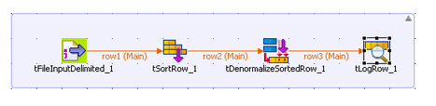
In the components tab of tSortRow, click the tab to add a column, from its drop down menu select the column in which you want to perform the sorting and select the ascending or desending orfer according to your preference.

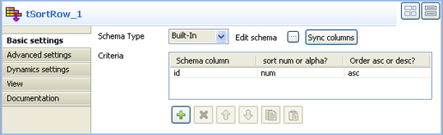

In the component tab of the tDenormalizeSortedRow
Click on the plus tab and include the column name which you want to denormalise.
If the row count field is empty, enter ((Integer)globalMap.get(“tFileInputDelimited_1_NB_LINE”))
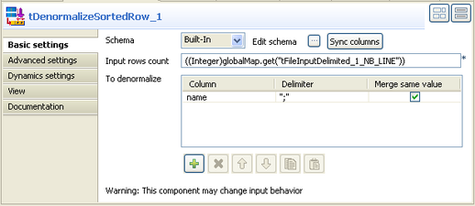

At last connect the tLogRow, to view the results.

Normalise data

Function | Normalizes the input flow following SQL standard.
Purpose | tNormalize helps improve data quality and thus eases the data update.

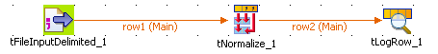
We will use a delimited file to denormalise its content

We can drag the delimited file from our metadata repository or by using the tFileInputDelimited component from talend palette.

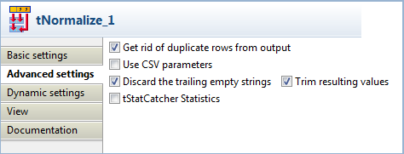

In the component tab of tNormalize check the schema, if necessary sync the schema with the input component.
In the Advanced settings view, select the Get rid of duplicate rows from output, Discard the trailing empty strings, and Trim resulting values check boxes.

At last, connect the tLogRow to view the result.

Number of Orders placed by customer

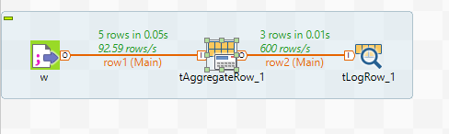

We will use a delimited file with the order information of customers to find the number of orders placed by customer.

We can drag the delimited file from our metadata repository or by using the tFileInputDelimited component from talend palette.

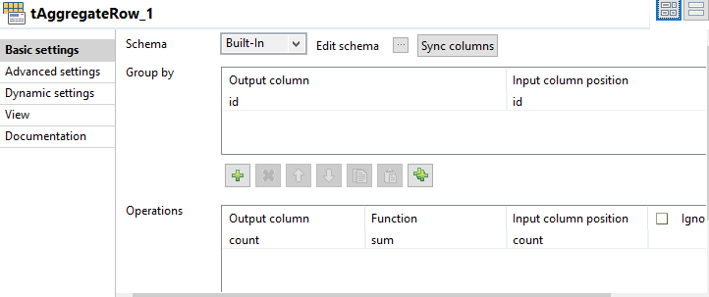
In the component tab of tAggregateRow component,
In the group by view, click the plus tab and add the column by which you want to group by (id of customer)

In the operation view of the, click the plus tab to add column and select the count of order column from the schema, for the function parameter ,select the function sum.

Al last, connect the tLogRow component to view the result

Here in this we have covered 4 questions they are as follow:-

- Taking the table from the database as the input to a new file.
- Updating the database with the new file.
- How to close a database connection after the whole work is done.
- How to and when to use rollback.

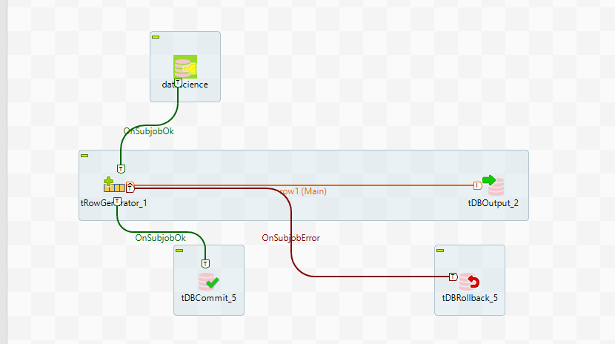

Step 1:-

Drag the database table schema directly from the table schemas that is present in the Metadata -> dbconnection ->table schema.
Here in the table schema I have stored a table called comics.

Step2:-

Right click on comics and click on trigger -> on subjob ok and select tRowgenerator from the drop down menu.

Step3:-

Here in this whole scenario you are taking the comics file as your input file.

Step4:-

Right click on t trowgenerator and click on row->main and select tdboutput from the drop down menu.
tdboutput is used for updating the file to a database.
So here we take comics as input file and we are returning the same file again to database so we will be having 2 comics file at the end of successful completion of job.

Step5:-

Right click on t trowgenerator and click on trigger->on subjob ok and select tdcommit from the drop down menu.

Tdbcommit helps you top close down a database connection after successful completion of the job.

Step 6:-

Right click on t trowgenerator and click on trigger->on subjoberror and select tdrollback from the drop down menu.

tdrollback is used to undo all the operation in database if the job fails to perform successfully. So that there is no harm put down to the database.

Snippets of different components settings are attached as follows:-

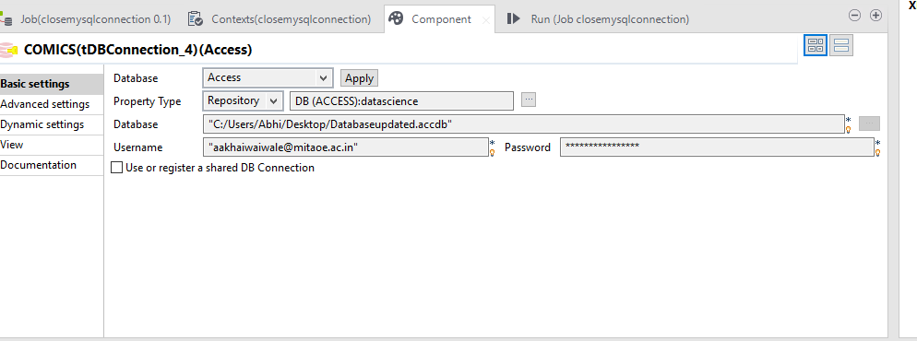

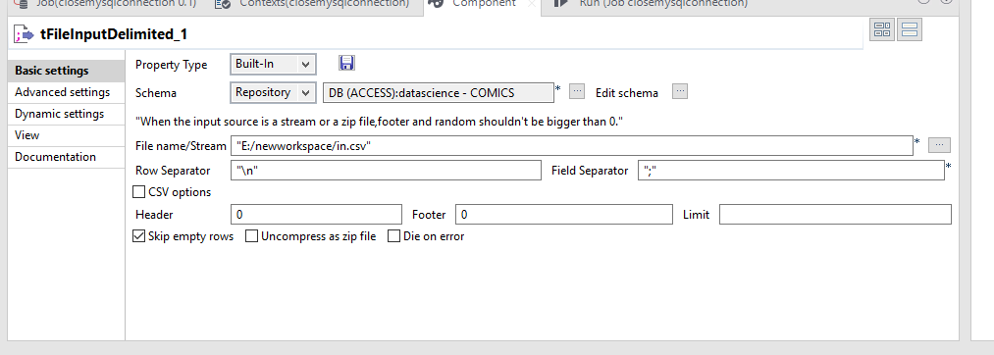

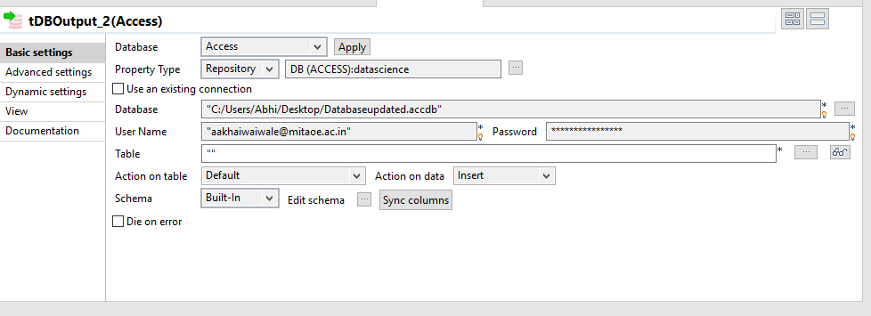

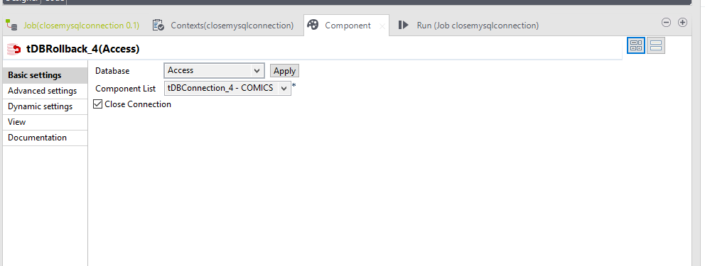

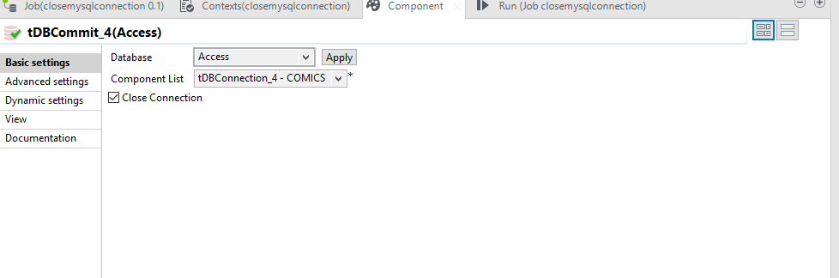

Create a Job that writes to and reads from cache memory

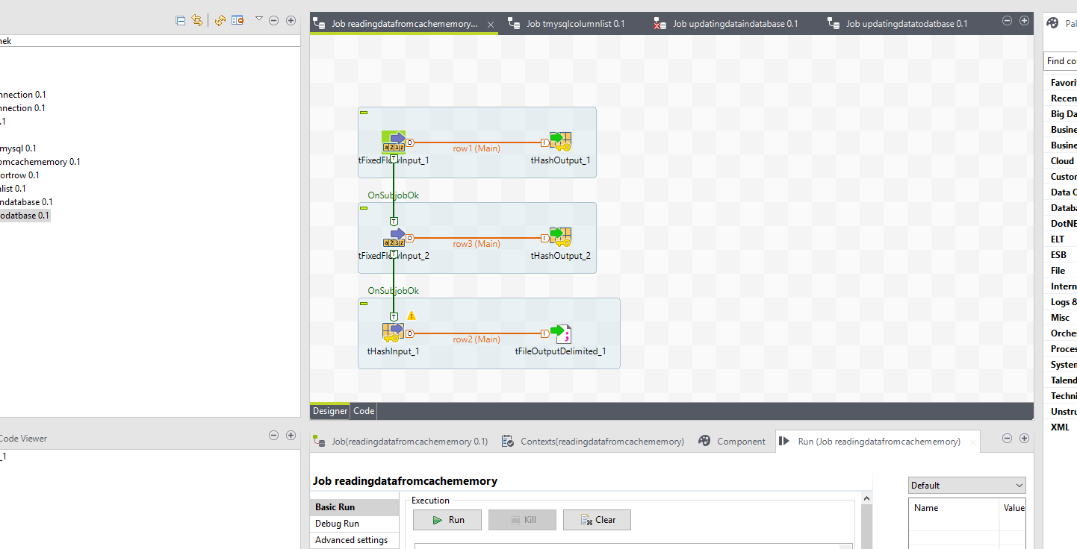

- Drag and drop the following components from the Palette to the workspace:

- tFixedFlowInput (X2), tHashOutput (X2), tHashInput and tFileOutputDelimited.

- Connect the first tFixedFlowInput to the first tHashOutput using a Row > Main link.

- Connect the second tFixedFlowInput to the second tHashOutput using a Row > Main link.

- Connect the first subjob (from tFixedFlowInput_1) to the second subjob (to tFixedFlowInput_2) using an OnSubjobOk link.

- Connect tHashInput to tFileOutputDelimited using a Row > Main link.

- Connect the second subjob to the last subjob using an OnSubjobOk link.

- Double-click the first tFixedFlowInput component to display its Basic settings view.
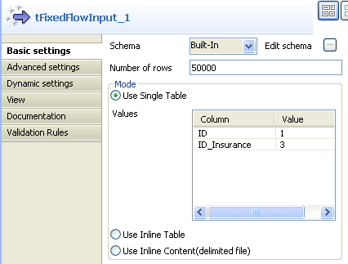
- Select Built-In from the Schema drop-down list.
You can select Repository from the Schema drop-down list to fill in the relevant fields automatically if the relevant metadata has been stored in the Repository. For more information about Metadata, see the Talend Studio User Guide.
- Click Edit schema to define the data structure of the input flow. In this case, the input has two columns: ID and ID_Insurance, and then click OK to close the dialog box.
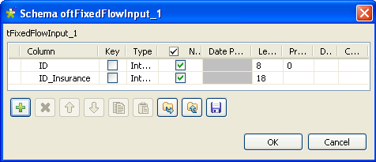
- Fill in the Number of rows field to specify the entries to output, e.g. 50000.

- Select the Use Single Table check box. In the Values table and in the Value column, assign values to the columns, e.g. 1 for ID and 3 for ID_Insurance.

- Perform the same operations for the second tFixedFlowInput component, with the only difference in the values. That is, 2 for ID and 4 for ID_Insurance in this case.

- Double-click the first tHashOutput to display its Basic settings view.
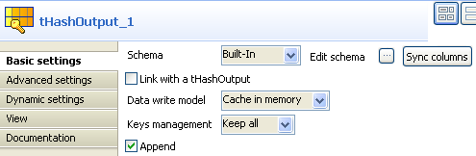
- Select Built-In from the Schema drop-down list and click Sync columns to retrieve the schema from the previous component. Select Keep all from the Keys management drop-down list and keep the Append check box selected.
- Perform the same operations for the second tHashOutput component, and select the Link with a tHashOutput check box.

- Double-click tHashInput to display its Basic settings view.
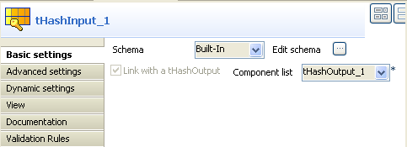
- Select Built-In from the Schema drop-down list. Click Edit schema to define the data structure, which is the same as that of tHashOutput.

- Select tHashOutput_1 from the Component list drop down list.

- Double-click tFileOutputDelimited to display its Basic settings view.
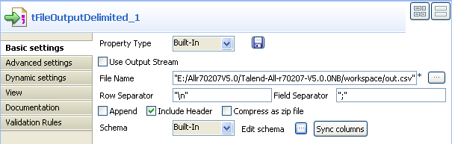

- Select Built-In from the Property Type drop-down list. In the File Name field, enter the full path and name of the file, e.g. "E:/Allr70207V5.0/Talend-All-r70207-V5.0.0NB/workspace/out.csv".

Create a Job to Sort Data Using tSortRow

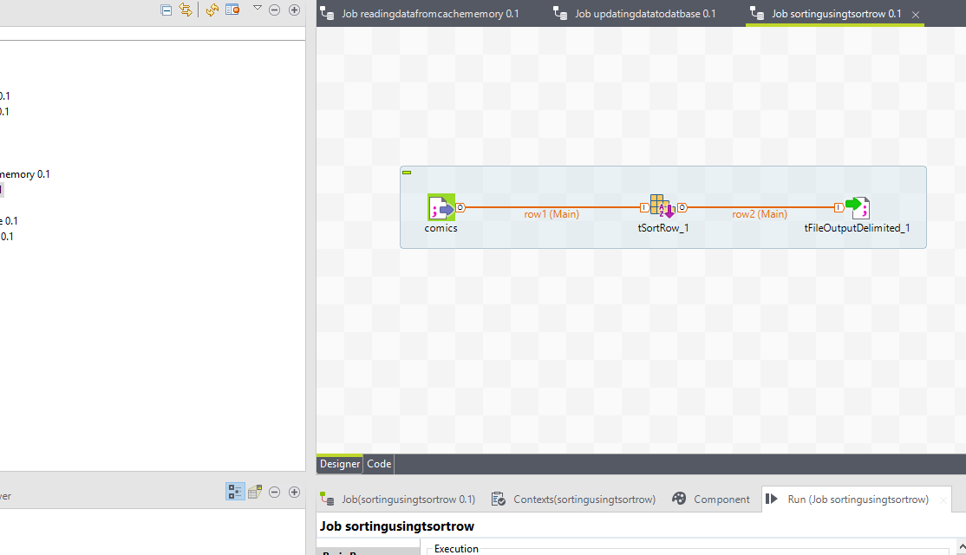

- Drop the three components required for this use case: tRowGenerator, tSortRow and tLogRow from the Palette to the design workspace.
- Connect them together using Row main links.
- On the tRowGenerator editor, define the values to be randomly used in the Sort component. For more information regarding the use of this particular component, see tRowGenerator

- In this scenario, we want to rank each salesperson according to its Sales value and to its number of years in the company.
- Double-click tSortRow to display the Basic settings tab panel. Set the sort priority on the Sales value and as secondary criteria, set the number of years in the company.

- Use the plus button to add the number of rows required. Set the type of sorting, in this case, both criteria being integer, the sort is numerical. At last, given that the output wanted is a rank classification, set the order as descending.
- Display the Advanced Settings tab and select the Sort on disk check box to modify the temporary memory parameters. In the Temp data directory path field, type the path to the directory where you want to store the temporary data. In the Buffer size of external sort field, set the maximum buffer value you want to allocate to the processing.

Some of the snipets of the settings are as follow:-

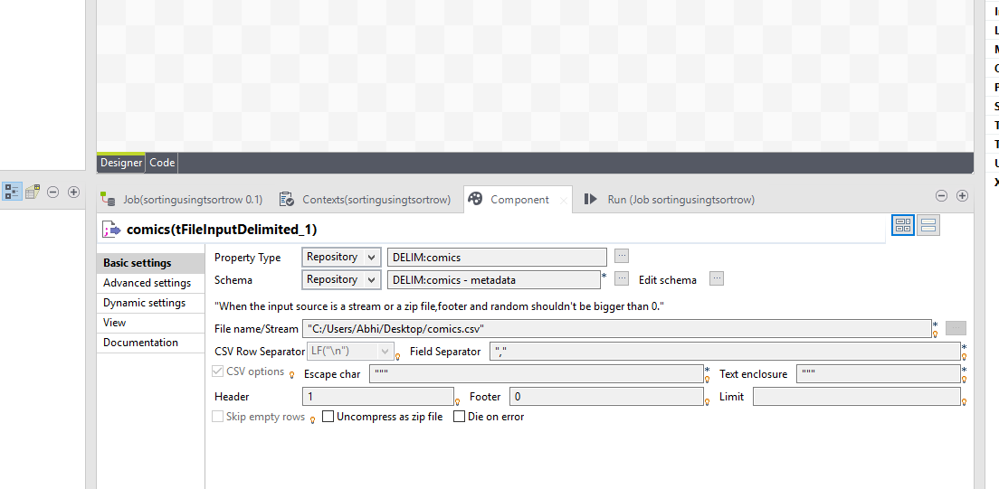

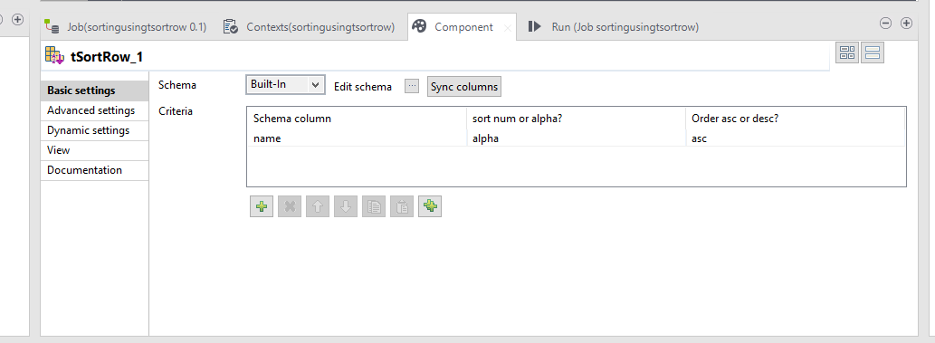

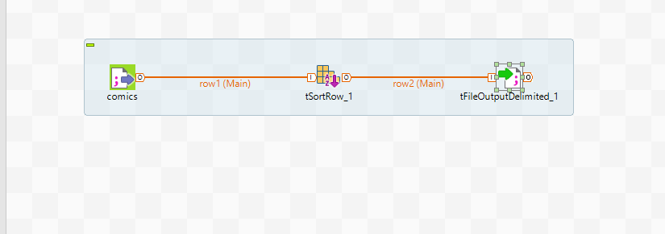

Database Connection with Microsoft Access Database:

- Expand metadata -> Right click on Database Connection -> Create New Connection.
- Fill all the fields click next.
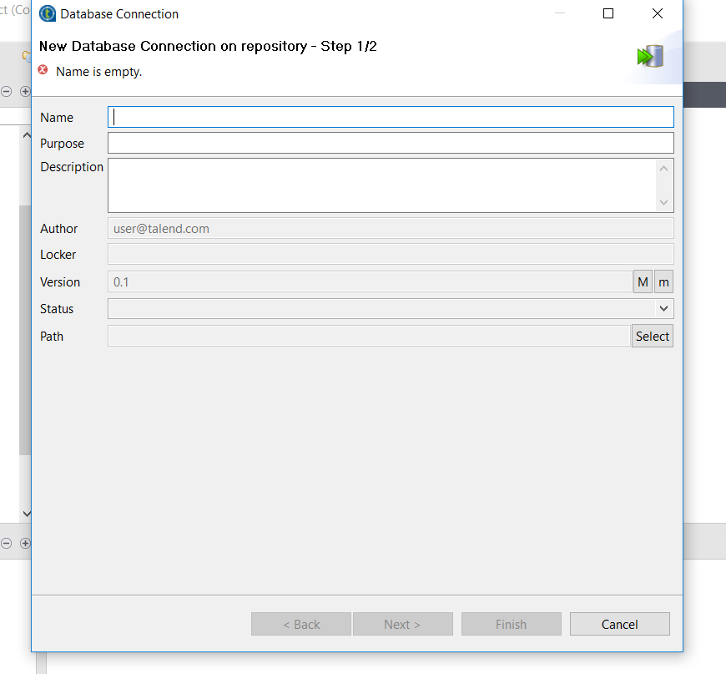

- Now, select database as Access and select DB file.
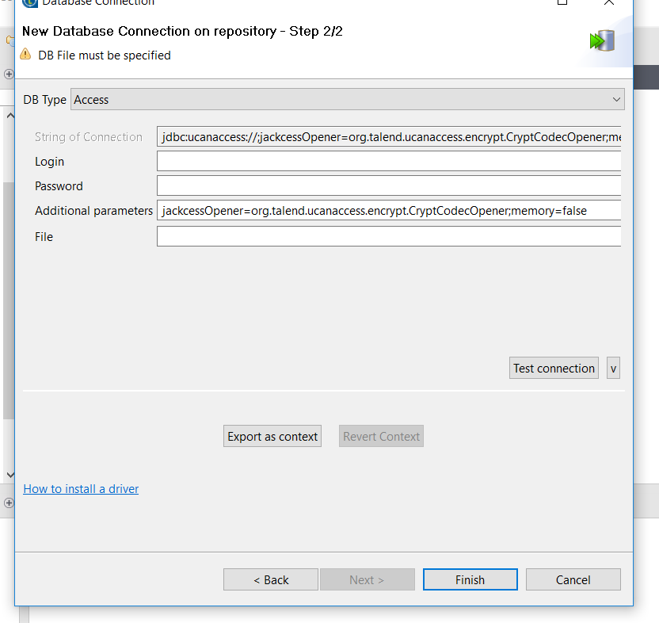

- Finish if connection is successful.
- Now create a job.
- Drag the database into pallet. Select DB Connection.
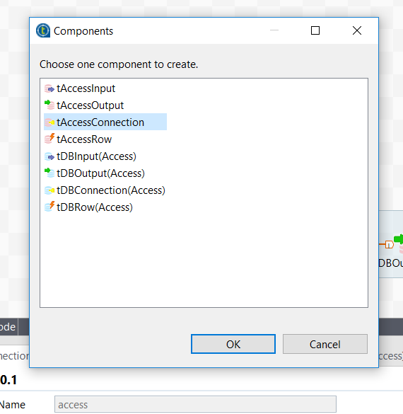

- Fill all the credentials:
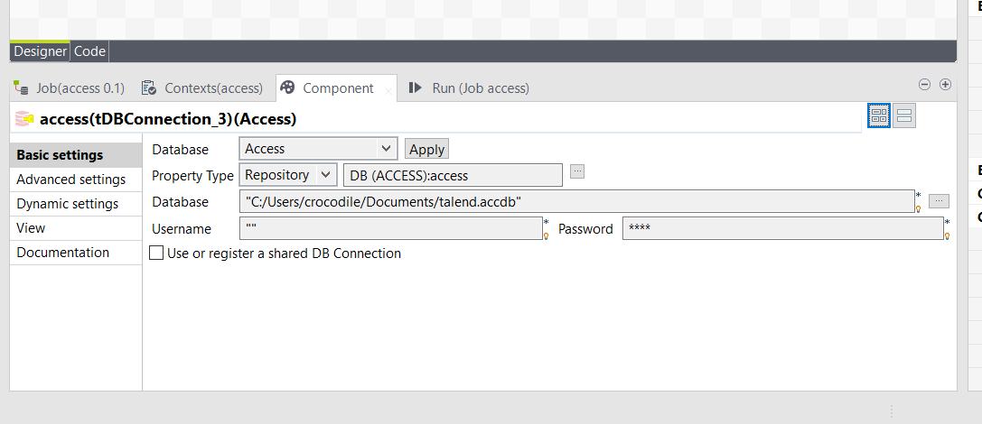
Right click Database and click retrieve schema:
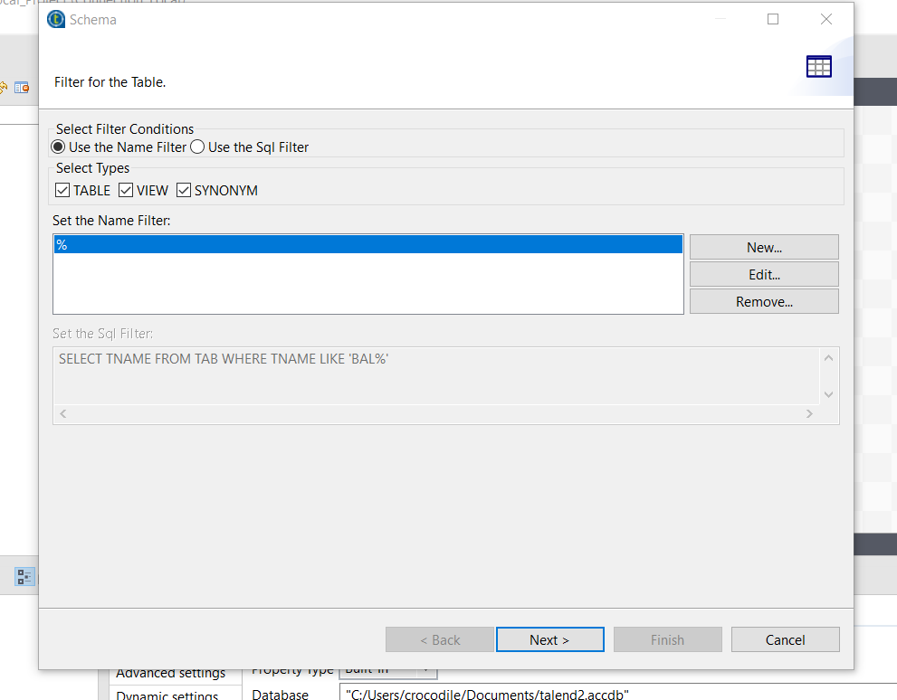

- Apply filter if any. Click next.
Now select tables you want and hit next.
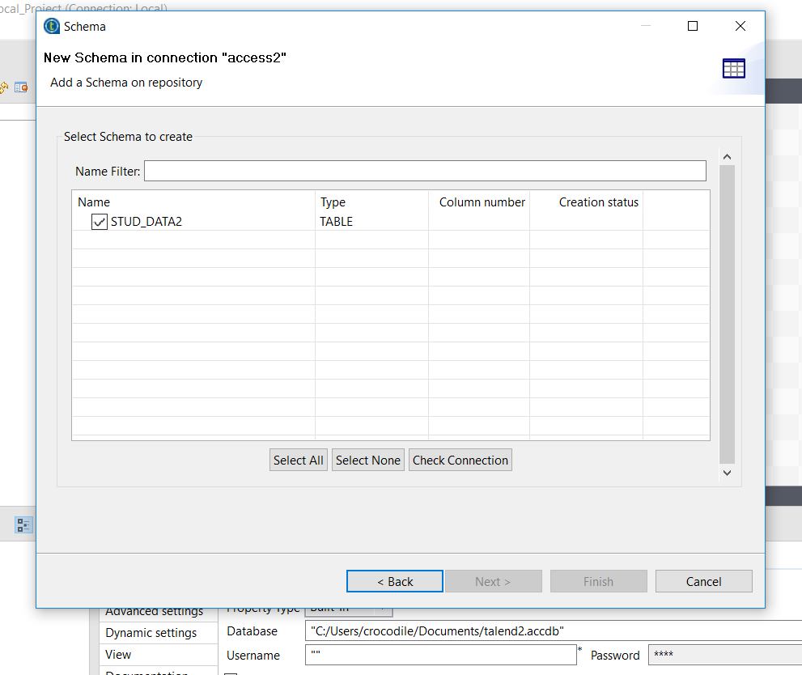

- Edit attribute if you want and add columns too (if any). Hit finish.
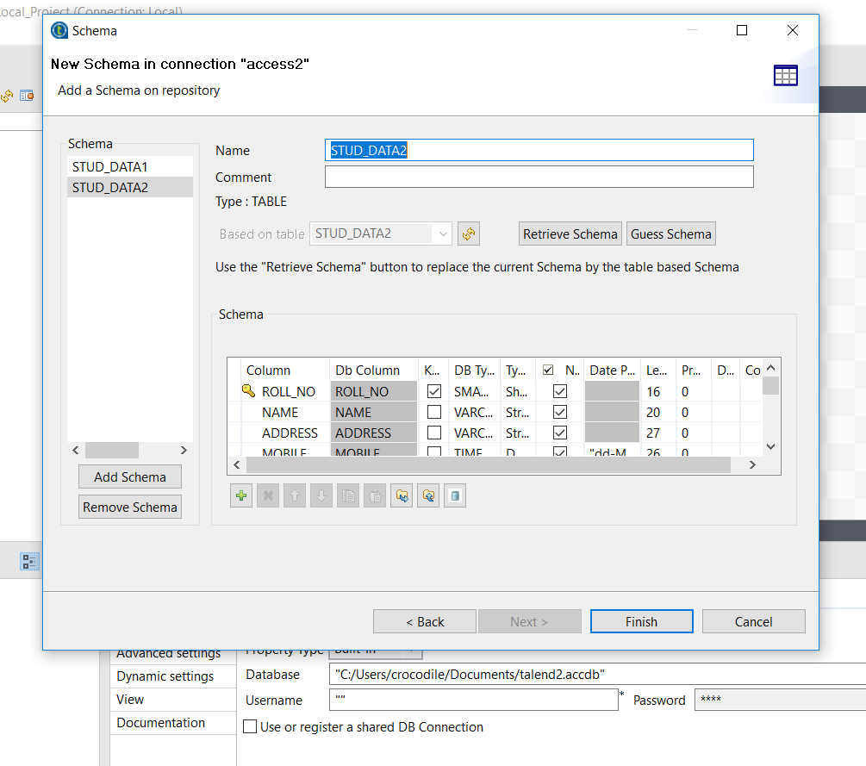
Done.

Insert update delete delimited file to database table.
Insert:
You need following components:
- tDBConnection(Access)
- tFileInputDelimited
- tMap
- tDBOutput(Access)

- make arrangement as following:
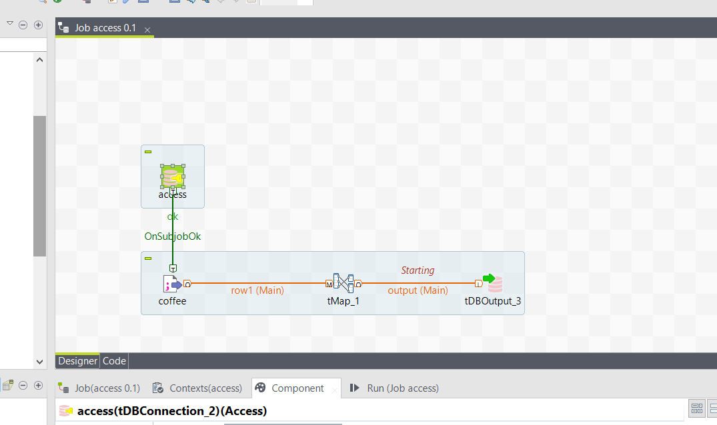

- Right click tDBConnection(Access) -> onSubjectOk -> tFileInputDelimited
- tFileInputDelimited -> row main -> tMap
- tMap -> main -> tDBOutput(Access)

- double click tMap:
drag attributes you need in output. Edit data types if needed. Hit finish.
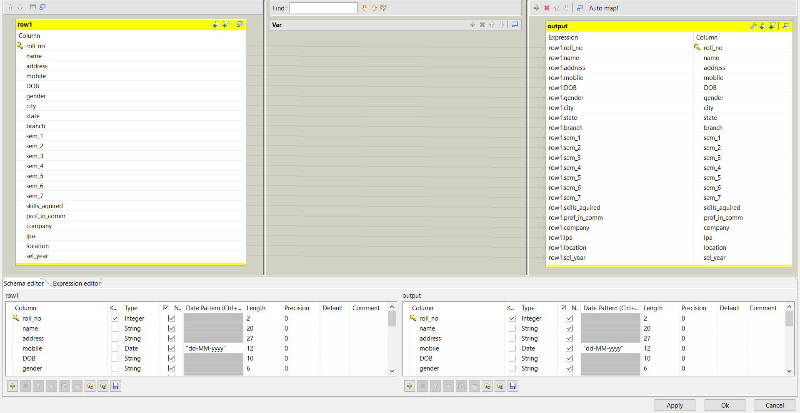

- Double click tDBOutput(Access):
- Select DB: access
- Property: Built in (because we have retrieved schema)
- Table name is mandatory
- Action on table : select wisely .. (depends on circumstances) I chose “create table” because there is none in DB.
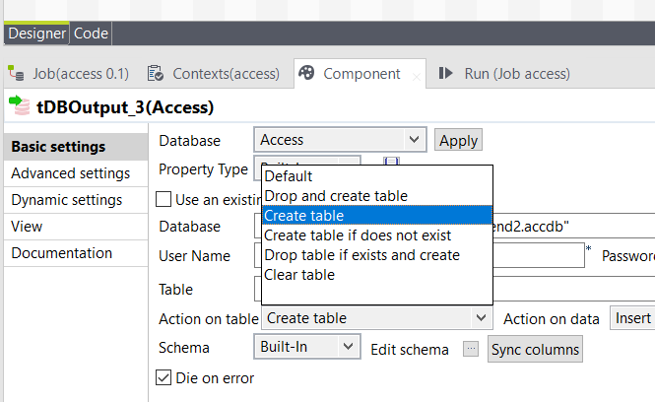
- Action on Data: Insert (very important)
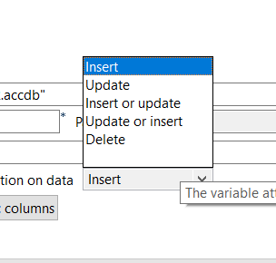

- Now run the job
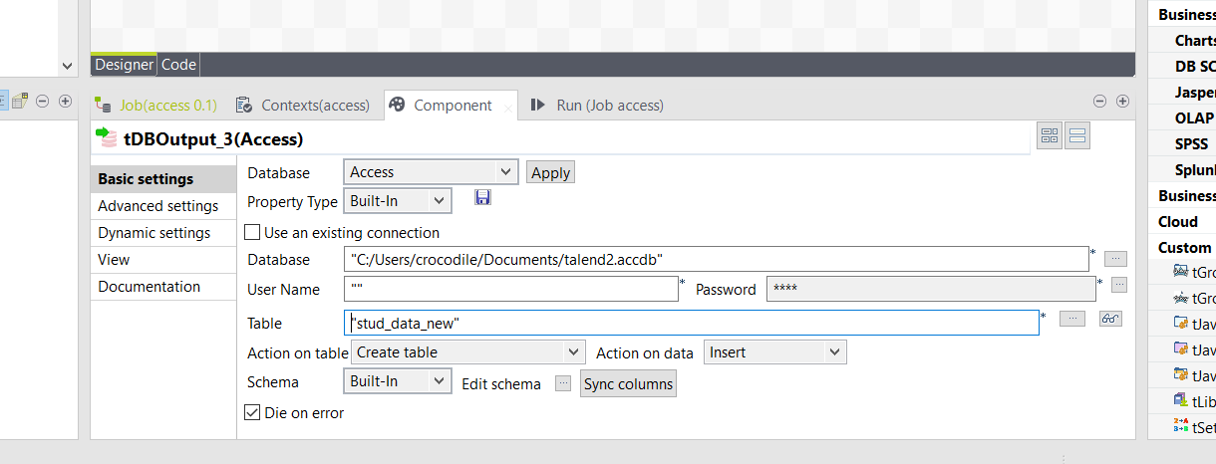
Now run the job
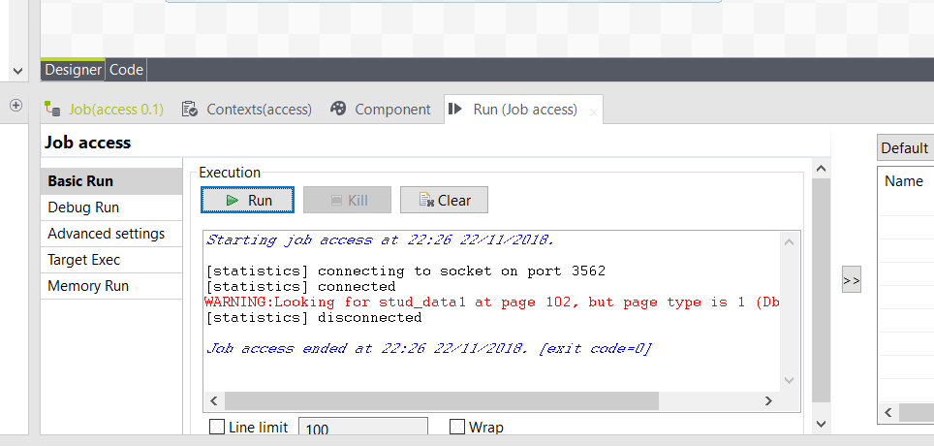
Warning does not mean errors.
See in access if table is created: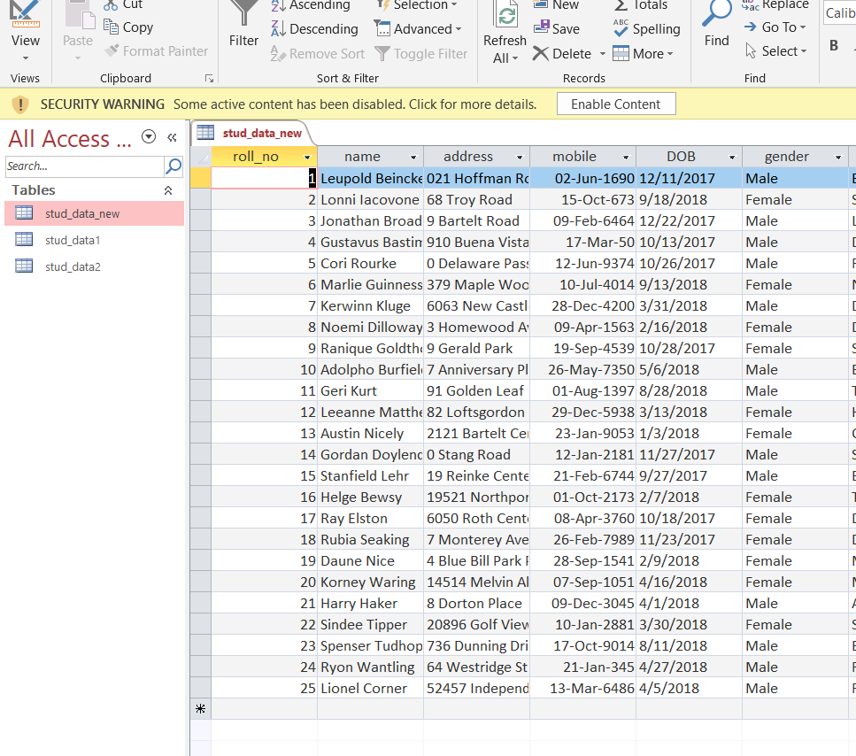
Update:
As what we did in insert select the , connect all the components only following things change:
tMap:
As what we did in insert select the , connect all the components only following things change:
Select the columns which you want to update. Reference would automatically point to primary key. And values would be updated.

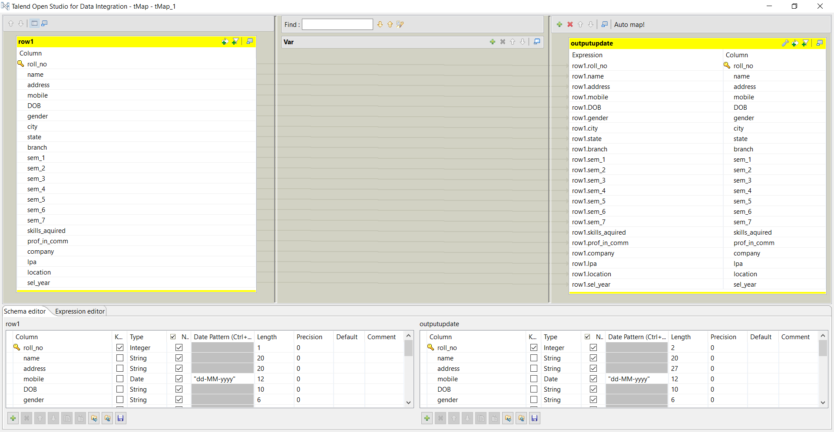

- Double click tDBOutput(Access): change the following fields
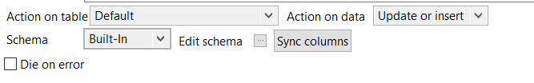

Run the job.

Delete:
- Do the same as in insert .
- Double click tDBOutput(Access):
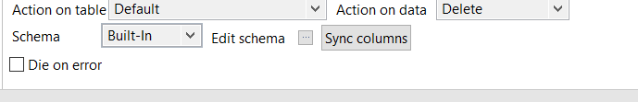

Run the job.
Display DB table content to console:
- Drag DB from metadata repository to pallet select following:
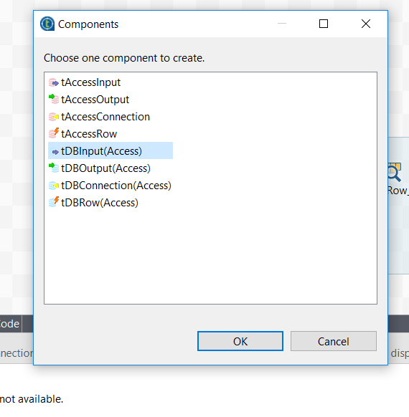
- Double click tDBInput(Access):
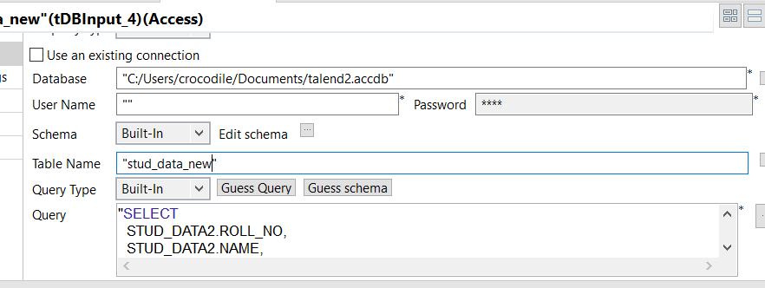

- Guess the query. Ensure that it is right.
- Drag tLogRow in pallet. Join the tDBInput(Access) and tLogRow by row Main.
- Double click tLogRow:
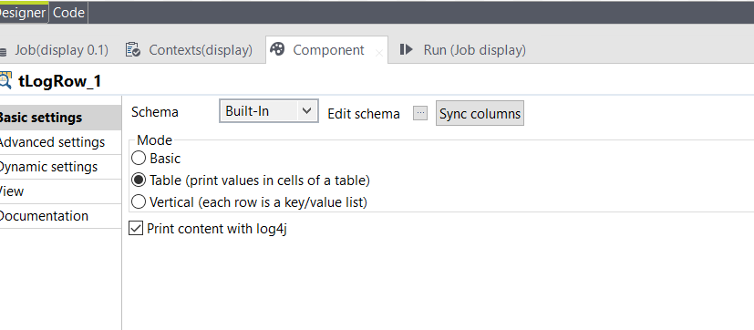
Run the job:
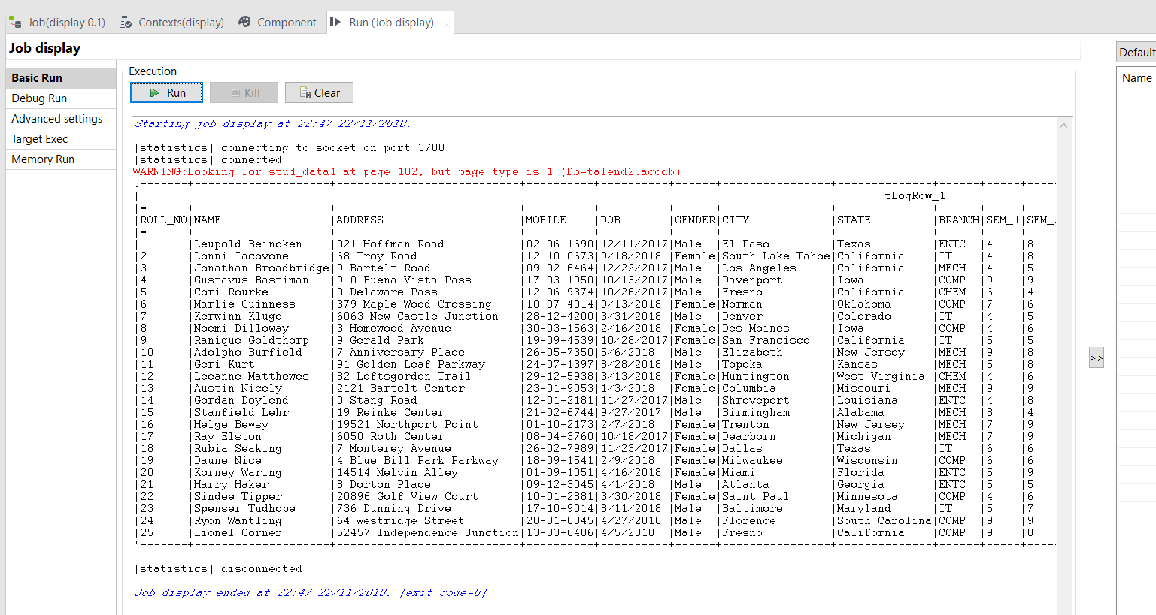

Convert any delimited file to XML:
You need following components:
tFileInputDelimited
tXMLMap
tFileOutputXML

- connect each component as following:
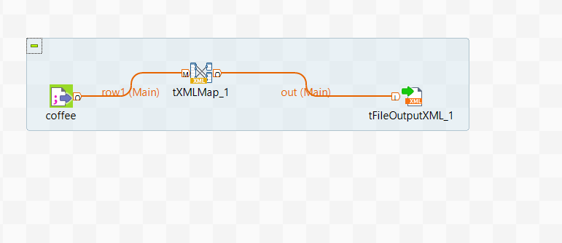

- Double click tXMLMap -> select the columns you want same as in tMap:
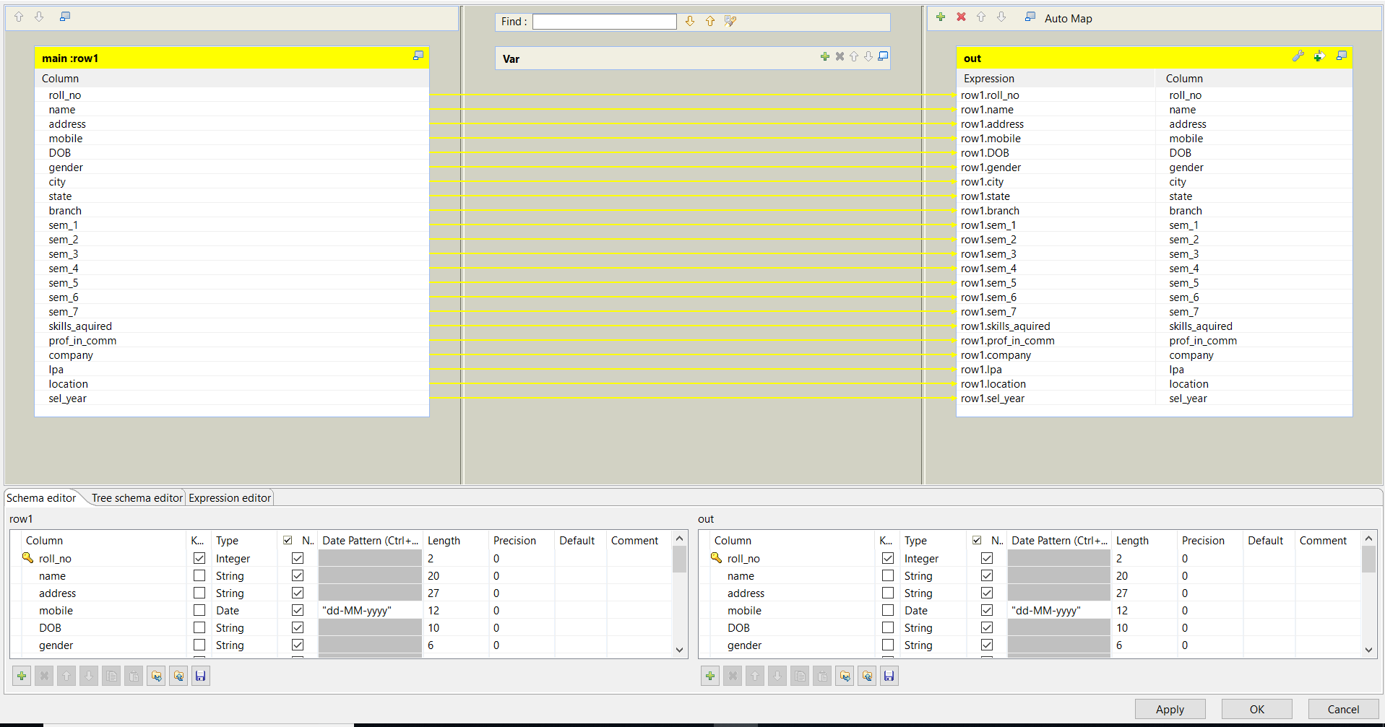

Double click tFileOutputXML :
Give output file location.
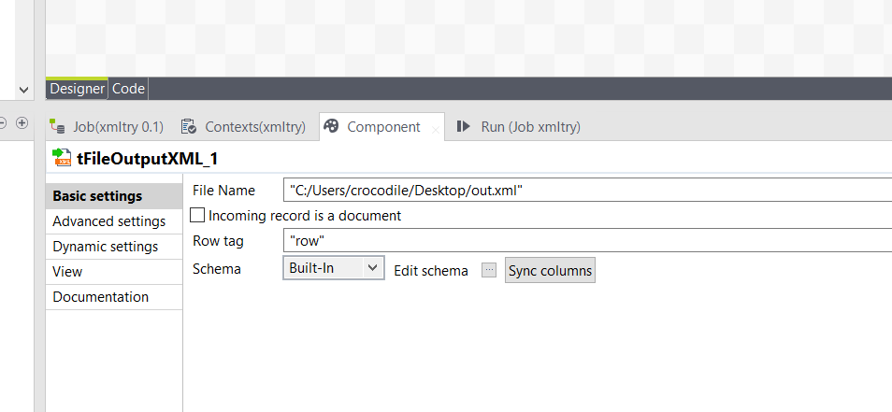

Run the job.
Output:
